

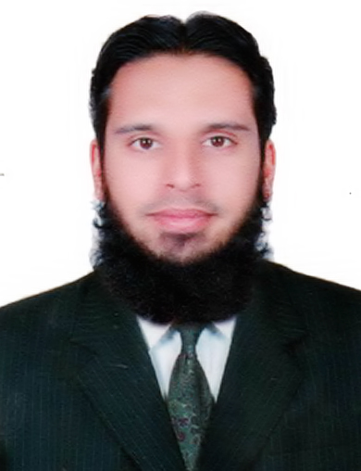**CURRICULUM VITAE**

**Apply for Light Vehicle Driver**

**ABDUL SUBHAN**

Mob No: +971508586123, +971528012434(UAE)

Dubai, UAE

E-Mail: subhansalam@yahoo.com

**Career Objective:**



To enhance a career that tests my professional abilities, add value and make an attempt to achieve organization and individual goals, also to further enhance my skills through learning and meet the challenges in any giving chance.

**Work Experience: 09 Years**



* Working as **Light vehicle driver** with Hard precast building system since 2019
* Worked as a **Camp Boss/maintenance in charge/Driver** with Bilal General Transport LLC Dubai, U.A.E from 2011 to 2017.
* Worked as a **CNC machine operator** with Al Shafar Contracting LLC Dubai from 2008 to 2011.

**Educational Qualification:**



* HSSC - Higher Secondary School Certificate.

**Personal Details:**



Name : Abdul Subhan

Father’s Name : Abdul Salam

Date of Birth : 15.06.1986

Sex : Male

Religion : Islam

Marital Status : Married

Nationality : Pakistan

Languages Known : Arabic, English, Hindi, Urdu & Panjabi.

**Passport Details:**



Passport No : AB 5040904

Date of Issue : 19.06.2019

Date of Expiry : 17.06.2024

Place of Issue : Pakistan

Visa Status : Employment Visa

**Driving License Details:**



License No : 1659832

Date of Issue : 06.02.2011

Date of Expiry : 06.02.2021

Place of Issue : Dubai

License Status : Light Vehicle (No.3) 

**Declaration**

I hereby declare that the above furnished information is true & correct to the best of knowledge & belief.

**ABDUL SUBHAN**