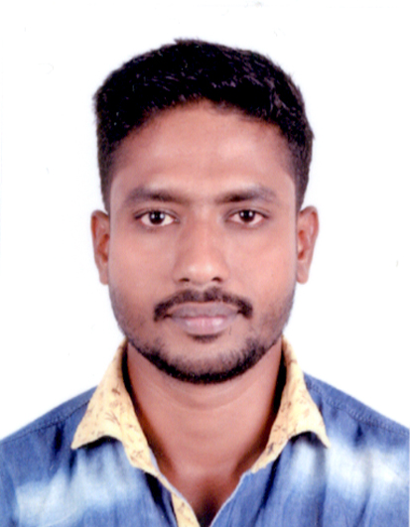CURRICULAM VITAE

JISHNU PRASAD
Email : jishnupillaijp4@gmail.com
Mobile : +91 9061444806

OBJECTIVES:
To emerge successfully in my career and take the organization to the greatest heights with hard work ,work experiences, high motivation and honesty.

WORKING EXPERIENCE

- 7year working Experience in Low Voltage System as Technician, (2year local , 2 yrs in Heights Electro Mechanical LLC Dubai (UAE) from 29 Sep 2014 to Dec.2017.Currently working SFFECO Saudi Arabia from march 2018 to till date.

OCCUPACTION OR POSITION HELD

TECHNICIAN

- Fire Alarm
- Central Battery System
- PAVA System
- CCTV
- Disabled Refuge Alarm System
- Access Control System
- Video Intercom & Automatic Gate system
- Biometrics

PROJECTS

- FOUR SEASON HOTEL, Abu Dhabi.
- AMMROK ,Alain
- Saudi Deffence Area Management Office, Hail
- St.Arnold International School,karnataka
- Royal valley Regent Hotel. Karnataka
- Kerala police Traffic CCTv survievlence.

DUTIES & RESPONSIBILITIES

- High level of concentration and commitment.
- Sharp techniques for troubleshooting
- Ability to work with the team spirit and to take responsibilities.
- Capacity to work in stressful and pressure situations.
- An excellent verbal and cross communication skills.
- Able to work under pressure & meet deadlines.
- Superior customer handling skills.
- High sense of time management.
- Self-Confident.
- Computer knowldge
- Able to prepare work reports.

EDUCATION QUALIFICATIONS:

- SSLC
- Plus Two
- Diploma in Electronics
- CCNA

PERSONAL PROFILE

- Father Name : Sasidharan Pillai
- Nationality : Indian
- Date of Birth : 04-10-1988
- Gender : Male
- Marital Status : Single
- Languages Known : English,Hindi,Tamil & Malayalam

PASSPORT DETAILS

- Passport No : M0940821
- Place of issue : Trivandrum
- Date of Expiry : 06/08/2024
- Visa Details : Employment

DECLARATION

I hereby certify that the above information are true and correct according to the best of my knowledge & My Experience. If selected I assure that I would perform to the best of my abilities, early awaiting a Positive response.

Jishnu Prasad.

