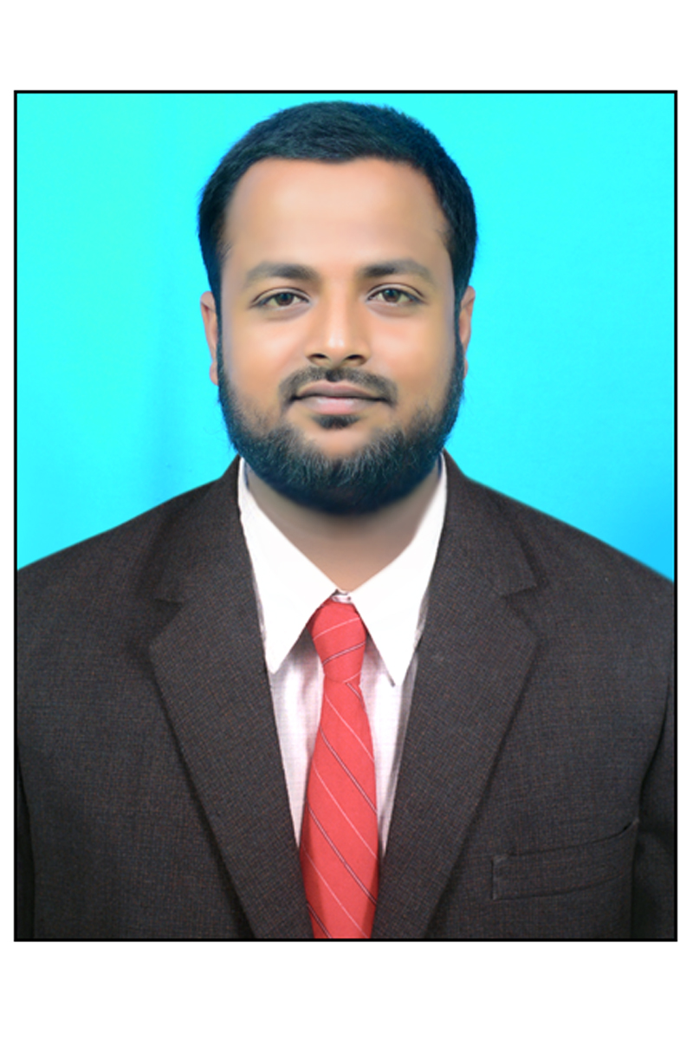

CONTACT
Address: Bangalore
Phone: +919916689656
Email: sameerkampli0@gmail.com

MOHAMMAD SAZEED

PROFESSIONAL SUMMARY

I am currently working as an Inventory controller Associate, Experienced In preparing documents and reports while managing complex Internal and external data analysis

WORK HISTORY

Inventory Controller Associate June 2020 -till date
Bangalore

SKILLS

- Microsoft Application
- Self-motivated
- Attention to detail
- Strategic Planning
- Problem-solving
- Process implementation
- Team player
- Time management
- Business Intelligence

- Ensure integrity and accuracy of the stock management system
- Manage Inventory control measures to ensure mistakes, inaccuracies and discrepancies are highlighted, addressed, and resolved.
- Maintain all documentation of Purchase Orders, pricing reports and inventory records in an organized manner.
- Produce daily reports to ensure key critical areas of the stock system are controlled and any discrepancies addressed and resolved.
- Perform random and surprise stock Audit, investigate and correct discrepancies in reported quantities, batch, and locations.
- Review Orders/Shipments below approved margin and get the management approval (wherever necessary) to proceed
- Monitoring inventory levels and replenishing stock as needed
- Perform critical inventory tasks to ensure the correct amount of items are in stock
- Providing stock reports on Category Level for All Stores
- Minimize overstocks and removal of obsolete / redundant stock to maximize availability of working capital.
- Liaising and negotiating with vendors and suppliers to ensure the quality of stock purchases.
- Daily monitoring of stock movement, running report of daily inventory adjustment

EDUCATION

- SSLC from SVN High School, kampli, with 73.2%
- Diploma in civil engineering, kampli, with 75.6

