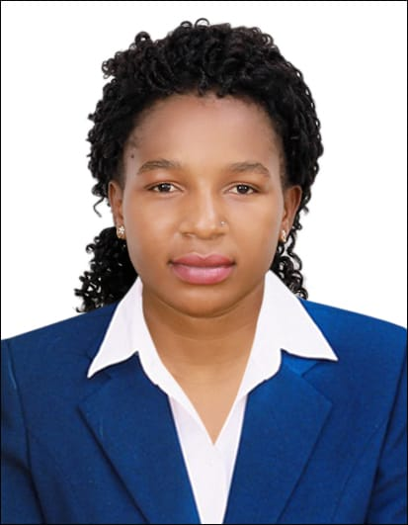

**EUNICE CHINENYANGA**

**Email: eunchinz@gmail.com**

**Phone :+971545035295**

**D.O.B 24 June 1994**

**PERSONAL SUMMARY**

Ensure high levels of customer service satisfaction,exceeding their expectactions and strong team player with an aappreciation and understanding of the importance of a customer.Proficient selling and assisting with the transfer and display of merchandiser.Proven ability to suggest,choosen,and help locate products based on guest need and desire.Successfully maintains current knowledge of a company product,marketing programs and promotions.A driven

**Professional Experience**

* Relationship building
* Strong proven retail sale background
* Strategic Planning
* Sales Goals Attainment
* Product Knowledge development
* POS system Knowledge
* Up selling skills
* Consistently meets sales goals

**(MAESTRO COUNTRY CLUB) June 2014 to January 2016 (ZIMBABWE)**

**Position Held: Waitres**

**Duties:**

* Welcoming and greetings guests
* Escort customers to their tables and ensure they are settled comfortably
* Pressenting the menu
* Suggestive selling,taking orders and serve food and beverages according to standard procedures
* Resetting tables and performing side work as required
* Explaining the preparation and cooking method as well as well as ingredients of various menu items
* Handling complaints
* Answering the phone and taking orders
* Maintaining cleaningless of work place by performing clearing function

**The following are my Accomplishments**

* Best waiter of the year by conducting product knowledgement
* Conducted product knowledge and customer service training to my colleagues.
* Fulfilled all supervisory duties in the absent of the manager
* Mentored new sales associates through product knowledge and customer service training
* Performed competitive analysis to make recommendations for company future growth

**(NETCAFE RESTAURANT BLAAUWBERG CAPETOWN SOUTH AFRICA)POSITION WAITRES**

* Welcoming and greeting guest
* Escort customers to the tables and ensure theya are settled comfortably
* Suggestive selling,taking orders and serve food and beverage according to standard procedures
* Present menu
* Inform patrons of the restaurants daily specials
* Explaining the preparation and cooking methods as well as ingridients of various menu

**Educational Qualifications RUSUNGUKO HIGH SCHOOL(ZIMBABWE)**

* Education Diploma in Purchasing and Supply
* Institution Mutare Poly 2011 - 2012