|  |
| --- |
| **Achny Karim** **Address:** Al waseet building, airport road, Abu Dhabi, UAE **Number:** +971529146543 **E-mail** : [karim.achny@gmail.com](mailto:karim.achny@gmail.com) |
|  |

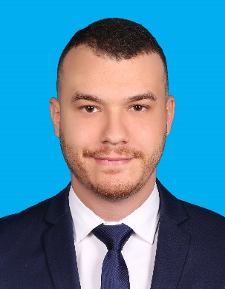

|  |
| --- |
| **Professional experiences** |

- **April 2017 - January 2019: *Quality auditor, Subject matter expert* at phone active part of Arvato “Social media moderation”.**

• I was in charge of leading a team of 18 agents to reach out the goals set by the company weekly.  
 • I had the opportunity to mentor, guide, motivate and reinforce the team spirit.  
 • I was responsible of making sure that the company’s rules and needs are being respected and fulfilled.  
 • Control and follow up the team’s attendance, behavior to ensure maximum of client’s and company’s satisfaction.   
 • Assisting agents in the platform if difficulties faced.

• Delivering new updates, calibrations sessions and trainings the new joiners.  
 • In charge of auditing the content worked by the moderators  
  
 - **January 2017 – April 2017: *Content moderator* at phone group part of Arvato “Social media moderation”.**

• Responsible to treat and work the content reported by the users as per the client’s requirement.  
 • Collect anything new trends and escalate them to the subject matter experts.  
 • Respect the work’s policy and maintain the quality set by the company.  
  
 **- April 2016 – January 2017: *Customer advisor* at phone group part of Arvato.**

• Manage large amounts of inbound and outbound calls in a timely manner.  
 • Follow communication “scripts” when handling different topics.  
 • Identify customers’ needs, clarify information, research every issue and provide solutions and/or alternatives.   
 • Seize opportunities to upsell products when they arise.   
 • Build sustainable relationships and engage customers by taking the extra mile.   
  
**-April 2015 – March 2016: *Sales representative* in Exist**

• Meet & Greet customers and offer assistance to ensure their needs are answered.  
 • Assist customers in their purchase decisions by helping them select relevant and appropriate products.  
 • Arrange and replenish on a continuous basis the shop shelves to ensure a tidy look at all times.

|  |
| --- |
| **EDUCATION** |

- **2014 – 2015: *Bachelor Degree in Management*** ***and Economics*** at Hassan II University Casablanca, Morocco.  
**- 2011 - 2013: *Two-years university degree in Management*** ***and Economics*** at Hassan II University Casablanca, Morocco.  
- **2010 – 2011: *Graduated High School in Accounting Management***

Casablanca, Morocco.

|  |
| --- |
| **SKILLS** |

- Excellent interpersonal and social communication skills.  
- Hospitality, Sales.  
- First Aid, Rescue,   
- Windows skills: Word / Excel / Power point / Outlook

|  |
| --- |
| **LANGUAGES** |

**-Arabic:** Native language.  
**-English:** Fluent.  
**-French:** Fluent