soumya v
VADAKKEKKARA (H) CHETHALUR (PO) MANNARKAD PALAKKAD
Email : soumya12052000@gmail.com , Mobile:9656771030
OBJECTIVE

An active and ambitious career in a position relevant to seeking for a career in a well-organized and established organization where I can develop expertise and analytical skills

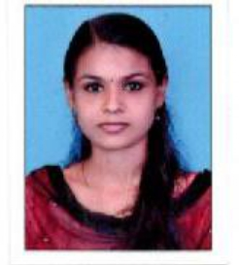
EXPERIENCE

Worked at tuition Centre for two years as a teacher

Education

sslc, PLUSTWO (COMPUTER science), DEGREE (B.A ENGLISH)

ACCOUNTING TALLY ERP.9

TTC HINDI

Skills
- Quick learner  - Good communication | - Teaching creative and lateral thinking  - Patience  - Hard working

languages

English, Malayalam, Tamil, Hindi

DECLARATION

I do hereby declare that the particular of information and fact stated here in above the correct and complete to the best of my knowledge and belief have got the confidence that will do my best in whatever field I am standing.

PLACE: Perinthalmanna

DATE: Yours truly,

SOUMYA. V

