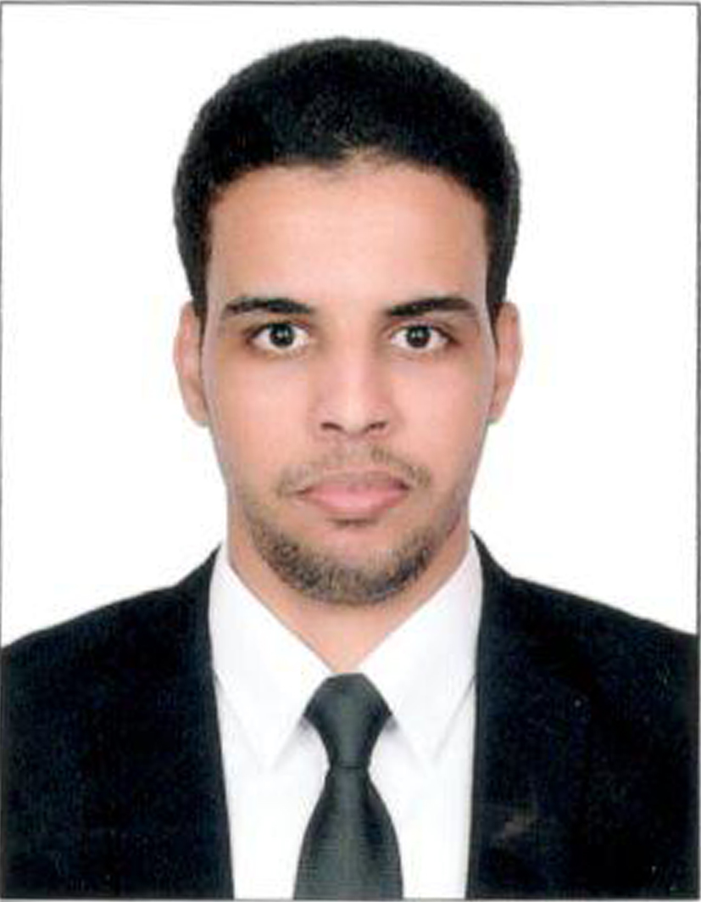
- Contact information
- Name : AHMEDOU EL HACEN
- Address : Al Karamah St. – Abu Dhabi- UAE.
- Mobile No UAE +971547125453
- E-mail: ahmedouhcn16@gmail.com
- Date of Birth : 13/11/1992
- Nationality : MAURITANIA
- Military Status : Exemption.

Objectives
I am looking for a position in a company where I enjoy work in the competitive and dynamic environment to utilize my potential and skills to enhance the company business

Education

- Certificate of B1 French from alliance Franco – Mauritania - 2014
- Bachelor’s degree of financial Accounting Section – Nouakchott university - 2013

Certificate of Course Completion and experience

- Practical and work at chinguitty – bank in local operations 2013 - 2015
- Windows, MS Office, Browsing internet, Networks.
- French Language year at alliance Franco -Mauritania
- Certificate from national security institute U.A.E 2015 (Security and safety)
- Emirates driving license 2017

Work Experiences

2016

- Work Place : financial Administrative - awqaf (UAE)
- Job Title : financial executive - sell representative .

- Job Description :

- Working closely with departments, increasingly in a consultancy role, assisting line managers to understand and implement policies and procedures.
- Planning, training including instructions for new staff.
- Preparing weekly accounting or liquidation of cash requests with accounts department for cache
- Updating all data in System related to Manger department.
- Preparing annual report related to M issues.

(From September 2013 to marsh 2015)

- Work Place : chinguitty – bank in mauritania
- Job Title : financial services officer

- Job Description :

- Transferring.
- Deposits and account opening and closing).
- Handling bank grantees transactions.
- Accounting
- Financial analysis
- internal audit
- Cost and value added accounting

LANGUAGES

  - ARABIC : language mother ENGLISH : excellent FRENCH : excellent

