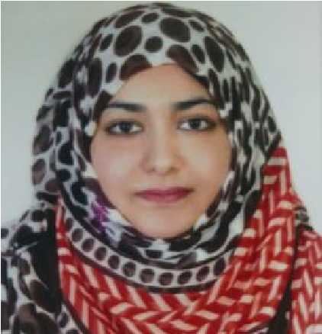

*Nadia Jamshaid*

Mob Num : +971-503731148

What’s app : +971-503731148

E-mail : fnsd091@gmail.com

# PERSONAL PROFILE

⮚ To get a Perfect Position in Growth-Organization & is talented, having good communication skills with proactive and high IQ/EQ.

⮚ To achieve a competent, prestigious position in the business community, taking the organization along with myself to the zenith.

CAREER OBJECTIVE

**Skywing Tourism, Dubai – UAE General ACCOUNTANT**

**Mar-2019 to Date**

* Answering phones from customers professionally and responding to customer inquiries and complaints.
* Researching required information using available resources.
* Handling and resolving customer complaints regarding product sales to customer service problems.
* Routing inbound calls to the appropriate resources.
* Following up complicated customer calls where required.
* Providing customers with the organization’s service and product information.
* Cash &Bank payment voucher.
* Invoice documentation.

**Green hills typing center**

**Accounts & typist**

**(Sep 2018 to Feb 2019)UAE**

Report to: General Accountant

Type: Manage All Account Entries and all types of typing

**Job Responsibilities**:

⮚ Maintaining Accounts, Details, Fees etc.

⮚ Making Salaries & payments to the staff, monthly/weekly basis.

⮚ Making the Monthly cash closing of the Cashier Cum Accountant.

⮚ Managing the all Customer Detail Responsibilities.

⮚ Meeting with All Customers.

⮚ Managing & paying all labour fees and Staff Salaries.

⮚ Prepare Cash Payment & Bank Payment Vouchers.

⮚ Making Excel Sheet that includes all the data of balances and payments to be made.

⮚ Preparing different applications/letters on letterheads.

⮚ Using the typing Software.

⮚ Make All invoices & Insurance documentation & visa documentation .

⮚ Check All mails.

⮚ Any other tasks assigned by the owner.

**Discount Car Repair General Accountant**

**(Jan 2015 to July 2018)UAE**

Report to: General Accountant

Type: Manage All Account Entries

**Job Responsibilities**:

⮚ Maintaining garage Accounts, Details, Fees etc.

⮚ Making Salaries & payments to the staff, monthly/weekly basis.

⮚ Making the Monthly cash closing of the Cashier Cum Accountant.

⮚ Managing the all Customer job Card Detail Responsibilities.

⮚ Meeting with All Customers.

⮚ Managing & paying all labour fees and Staff Salaries.

⮚ Prepare Cash Payment & Bank Payment Vouchers.

⮚ Making Excel Sheet that includes all the data of balances and payments to be made.

⮚ Preparing different applications/letters on letterheads.

⮚ Using the garage Software.

⮚ Make All invoices & Insurance documentations.

⮚ Check All mails.

⮚ Any other tasks assigned by the owner.

**Azmat And Associates (Auditor sale and Income Tax Officer) (2013 to 2015)in pakistan**

Report to: Accountant – Client Relations

Type: Auditor, Accountant Tax Consultants

**Job Responsibilities**:

⮚ Maintaining Bank Accounts, Details, Statements etc.

⮚ Managing & paying all parties through Chaque, Online & Cash.

⮚ Prepare Cash Payment & Bank Payment Vouchers.

⮚ Making Excel Sheet that includes all the data of balances and payments to be made.

⮚ Preparing different applications/letters on letterheads.

⮚ Preparing final data regarding Purchases.

⮚ Making Salaries & payments to the staff, monthly/weekly basis.

⮚ Checking the Daily cash closing of the Cashier Cum Accountant.

⮚ Maintaining & Updating Parties Ledger/Balances & entering data on Telly Software.

**Pace College Of Commerce Pakistan Account Manager**

**(May 2009 to May 2013)**

Report to: General Accountant

Type: Manage All College Activates

**Job Responsibilities**:

⮚ Maintaining College Accounts, Details, Fees etc.

⮚ Making Salaries & payments to the staff, monthly/weekly basis.

⮚ Making the Monthly cash closing of the Cashier Cum Accountant.

⮚ Managing the all College Playing and Parties Responsibilities.

⮚ Meeting with All Students Parents.

⮚ Managing & paying all Students fees and Staff Salaries.

⮚ Prepare Cash Payment & Bank Payment Vouchers.

⮚ Making Excel Sheet that includes all the data of balances and payments to be made.

⮚ Preparing different applications/letters on letterheads.

⮚ Making All Courses Diplomas in collages.

⮚ Any other tasks assigned by the Principal.

# EDUCATION

2013 - 2014 B.com

(Punjab University)

2006 - 2008 I.com

(Board of Intermediate Secondary Education Gujranwala, Gujrat)

2004 - 2006 Computer Science group,

(Board of Intermediate Secondary Education Gujranwala, Gujrat)

# SKILLS SYNOPSIS

⮚ Computer: *Software--------*MS Office (Word, Excel), work on windows based Programs, operating system & Tellay data entry

*Hardware-------*System Maintenance, Windows/Driver Installation

⮚ Communications: Oral, non-verbal, Written Communication.

# OTHER SKILLS

⮚ Strong Leadership/Managerial Skills

⮚ Self-Motivated/Target Oriented

⮚ Hardworking, Efficient and Proficient

⮚ In page , Adobe Photo Shop

⮚ Work loving and responsible

LANGUAGES

English (fluent), Urdu (fluent), Punjabi (good)

# PERSONAL INFORMATION

* DOB: 16th November, 1990
* Marital Status: Married
* Nationality: Pakistani
* Religion: Islam
* Passport # AK8210651
* Mailing Address alqouz behind bowling center.
* Visa status husband visa