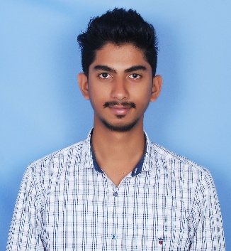

**RESUME**

Mr. **Syed Shoaib**

Ward NO - 3 Big

Mosque Street

Holenarasipura

Hassan Dist,

Phone (M) **:** 8971500625

E-Mail id **:** [Aryann0625@gmail.com](mailto:Aryann0625@gmail.com)

**OBJECTIVE**

Looking for challenging career, with wide scope of achievement, always on a look out for a positive & bigger outlook, currency are ideas, thrive on Imagination & Passion, Rigorous thinking and boundless curiosity, Sets levels & standards that exceed expectations, Have fun Attitude is everything, Bottom line rises with the Organization, A Learner for life.

**EDUCATION DETALIS**

|  |  |  |
| --- | --- | --- |
| **QUALIFICATION** | **INSTITUTE** | **UNIVERSITY / BOARD** |
| SSLC | **Sri Amar Vidya Samsthe ®** | Karnataka Secondary Education Examination |
| ITI | **New Horizon Industrial Training Institute** | Directorate General of Employment & Training (DGET) |

**EXPERIENCE DETALIS**

|  |  |  |
| --- | --- | --- |
| **COMPANY NAME** | **DESIGNATION** | **PERIOD** |
| **MADEENA EARTH MOVERS & CONSTRUCTION** | As a Co-Proprietor For Hitachi & JCB & Maintains In charge & Labor In charge | 24.03.2016  To  02.02.2018 |
| **ZAM ZAM JEWELLERS** | As a Gold Auction Bidder & Accountant , Maintain Office Works & all | 05.02.2018  To  19.11.2020 |
| **Centum Guru** | As a Sales Manger | 03.12.2021  Presently Working |

**HOBBIES**

* Learning Creative
* Innovative Things & Trying To ExecuteIt
* Reading Books
* Doing Adventures in life
* Travelling & Driving
* Cooking

**I HAVE KNOWLEDGE IN**

* Microsoft (Power Point, Word)
* Excellent Conversational/Telephone Skills
* Construction Field
* Sales & Marketing Field
* Team Handling Experience
* Maintain Stock Level In Stores
* Keep Record Soft Copy And Hard Copy
* Good Communication Skills-Written & Verbal
* Ability To Speak And Understand English Fluently
* Have Flair To Learn New Things
* Key Mentor For New Comers
* Positive Attitude & Fast Learner
* Team Player
* Critical Thinker And Problem-Solving Skills
* Excellent Knowledge About Latest Tourism Trends

**PERSONAL DETAILS**

Name : Mr. SYED SHOAIB

Father's Name : SYED KAASIM

Mother's Name : AKTHER UNNISA

Date of Birth : 01-06-1999

Sex : Male

Marital Status : Single

Religion : Islam

Languages Known : English**,** Hindi, Urdu, & Kannada :

Indian Driving License No : KA1320190003990

**PASSPORT DETAILS**

|  |  |  |  |
| --- | --- | --- | --- |
| **Passport No** | **Date of Issue** | **Date of Expiry** | **Place of Issue** |
| V 1 5 8 0 7 7 5 | 30/07/2021 | 29/07/2031 | BENGALURU |

**DECLARATION**

I Syed Shoaib hereby declare that, the above information furnished by me is correct up to my knowledge and I bear the responsibility for the correctness of the above mentioned particulars.

Place: Holenarasipura

Date: 16-08-2021 Signature

**(**SYED SHOAIB)