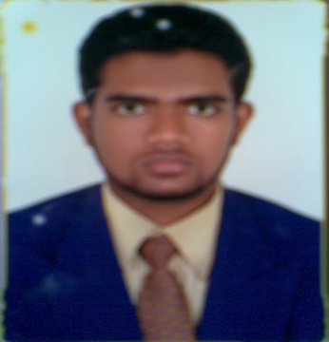

**Curriculum vitae**

**Taha AHMED**

S/o GHULAM KHADER **E-mail: taha.ahmed14@gmail.com**

HYDERABAD **Contact No: 8885617854**

|  |
| --- |
| **OBJECTIVE** |

­­­­­­­­Looking forward to a mutually beneficial association with a group of dedicated people bond by a common thread. The challenge of taking business forward in a competitive atmosphere. I view my career as a means to growth all walks of life.

|  |
| --- |
| **DRIVING LICENSE** |

* **Holding a valid UAE Driving License.**
* **Indian driving licence.**

|  |
| --- |
| **EDUCATIONAL QUALIFICATION** |

* **12th Standard: Higher Secondary Education (Intermediate):** Board of Intermediate Education, Hyderabad, A.P India.
* **C.B.S.E (Central Board of Secondary Education):** Institute: Comprehensive Education Institute, Dubai, UAE.

|  |
| --- |
| **CAREER PROFILE** |

* WORKED in **“U.A.E. Municipality”** (Waste Management Department) as a **“Cashier cum Weigh Bridge Operator”**, since December 2010 to December 2022. Worked for dubai, sharjah, ras al khaima municipality.

**Job Profile:**

* Data entry in the system for issued ticket to the customer.
* Receiving the cash from customer and issuing them receipt for dumping the waste.
* Allowing all vehicles to go for burying and crushing the waste at provided area.
* Operating front office as handling the telephone calls and enquiries.
* Maintaining of filing system in office and maintaining the pantry.
* Supervising for the maintenance & cleaning system of office.
* Flexible with shift duty.

|  |
| --- |
| **HOBBIES** |

* Listening to music, Interact with new people, Reading Newspaper and Travelling.

|  |
| --- |
| **STRENGTH** |

* Willingness to learn sharply
* Sincerity, Honesty and Hardworking,
* Ability to work individually or with a team
* Ability to deal with people diplomatically
* Ability to work under pressure and meet tight deadlines

|  |
| --- |
| **PERSONAL PROFILE** |

Name : **Taha Ahmed**

Father’s Name : Ghulam Khader

Date of Birth : 12th Oct 1991-dubai.

Nationality : Indian

Religion : Islam

Sex : Male

Marital Status : Married

Languages Known : English, Hindi, Arabic, Urdu.

|  |
| --- |
| **DECLARATION** |

In the view of the above I request you to be kind enough to give an opportunity to serve in your esteemed organization in the capacity mentioned above, for which act of kindness I shall be very thankful and grateful to you.

I hereby declare all that information furnished and particulars are true and correct to the best of my knowledge and belief.

**Thanking you**

**Place: Hyderabad**

**Date: (TAHA AHMED)**