C U R R I C U L U M V I T A E

BANDELA AJITH 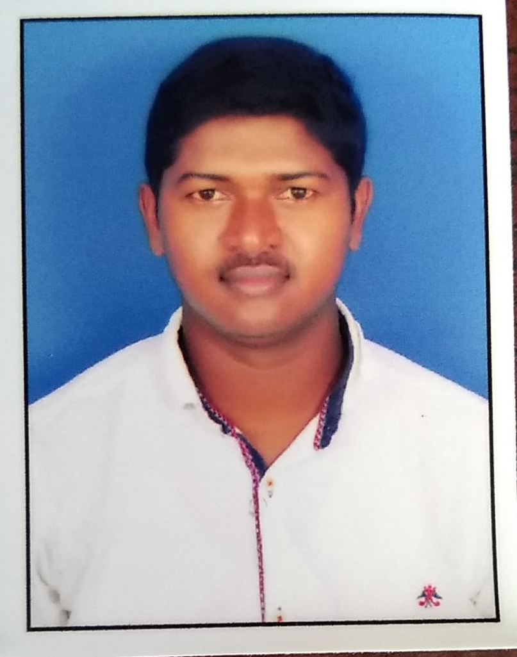
S/o. MUTTHAIAH
HNO: 4-30,
(V) REGUNTA
(M) MALLAPUR- 505460, Email: ajithbandela8@ gmail.com
Dist: Jagtial, (T.S) Contact: +91 7093497616
Career Objective:
Seeking a challenging environment to utilize my skills as a person involved in a Industry that encourages continuous learning and creativity, providing exposure to new ideas, which stimulates professional and personal growth

Education:

- SSC from Z.P.H.S at Sataram on 2007 passed out.
- Inter (MPC) from SARALA Junior College at Metpally on 2010 passed out.
- Graduation (B.Sc.) from Sri Acharya Nagarjuna University 2013 passed out.
Work Experience:

- Worked in Fino as a Enrolment Operator from 2012 to 2013
- Worked in MANDAL REVENUE OFFICE as a System Admin at Mallapur from 2016 -19.
- Worked in M/s Vinayaka Constructions as a Supervisor at Korutla 2019-20
- Worked in M/s Maruthi Power Projects as a System Admin at Sirikonda 2020-2021 till date

Profile:

Name : B.AJITH
Fathers Name : MUTTHAIAH
Date of Birth : 15/06/1991
Sex : Male
Marital Status : Married
Nationality : Indian
Religion : Hindu
Language Known : English, Hindi and Telugu

Declaration:

I am confident of my ability to work in a team. I hereby declare that the information furnished above is true to the best of my knowledge.

Place:
Date: / / 2021. (B. AJITH)

