RESUME
JUSTIN JOHNSON  - +971 581710401  - justinjohnson2020@gmail.com  PERSONAL DETAILS  Date of Birth : 28.06.1980  Address :13/1,9B Street, Alraffa  Bur Dubai  Nationality :Indian  Gender : Male  Languages Known : English, Tamil and Malayalam  Visa Status : Visitvisa | 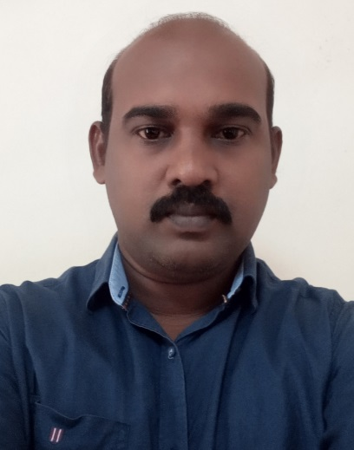

OBJECTIVE

To become a highly skilled professional and develop an ability to adapt to today’s ever changing intellectual and technology driven environment. Realize challenges with dedication and innovation and work in an environment which expands my technical prowess.

SKILLS

1 | Knowledge in MS Office Software Package
2 | Knowledge in Sabic Standards
3 | Work Permit receiving cards from SAUDI BASIC INDUSTIES COPORATION. (SABIC).
4 | Knowledge in Singapore Electrical Standard and Regulation CP5 & CP88
5 | Singapore Class 3 driving License
6 | Holding Singapore BCSS

WORK EXPERIENCE
1 | Organization: H.K.AL SADIQ SONS CONTRACTING CO LTD ,Saudi Arebia.  Duration: December 2007 – January 2012 (5 years)  Role : Site Supervisor( Electrical /Instruments)  Type of Structure : Industrial  - Client : SIPCHEM- SAUDI INTERNATIONAL PETROCHEMICAL COMPANY  Duration : December 2007 to December 2009  List of Projects  - Jubail Acetyl Complex (JAC) Above ground Services Project. (24 new pipe lines)  - Cladding and Roofing for AA &VAM Plant.  - Communication Control & Power Interface Project.  - Client : SABIC (Saudi basic industrial corporation ) in safco / ibb plants  Duration : December 2009 to December 2011  List of Projects  - UGAA(Urea granulator ammonia abatement) project in SAFCO plant (Saudi Arabia)  - Flare Project in IBB (ibn al-baytar) plant  Activities undergone as Site Supervisor:  - Motor installation, Transformer installation, MCC/DCS panels & junction box installation, conduiting and cable installation & termination, Transformer installation, MCC/DCS panels & junction box installation  - Conduiting and cable tray works, instrument works, transmitters and control valve installations  - Cable insulation testing and loop checking, cable pulling, termination, street and security light post fixing and termination  - Cathodic protection for underground pipelines, aviation lighting for flare system  - Ignition panel installation commissioning and installation of grounding for cladding structure.  Roles and Responsibilities (includes but not limited to)  - Review Scope of work and drawings per client standards.  - Prepare material take-off.  - Verification of materials received for construction.  - On Site Job execution & Crew Supervision.  - Identify / resolve resource requirements of Projects.  - Prepare Timesheets & Material Requests.  - Employee Assessment.  - Execution & supervision of the daily work.  - Execution & Supervision of other projects handled by the company.
2 . Organization: Feng Ming Constructions PTE, LTD, Singapore.
Duration: September2014 – February 2022 (7 years)
Role : Site Engineer/Supervisor(Electrical)
Type of Structure:Construction(Infrastructure)
List of Projects
- Electrical works at Rochar Canal Project
- Electrical works at Marina Central Area Project
- Electrical works at Alexandra Canal Project Site Office as follows:
- Electrical works at Upper Bukit Timah Project(ER 480) Site Office
- Electrical works at Hindhede Project Site Office as follows:
- Electrical works to the new Project N109A- Road Diversion works as follows:
- ER-410
- ER-431

Responsible for overseeing the installation and maintenance of electrical devices wiring in a wide range of various Projects site offices.
- Making repairs to appliances, installing electrical wiring in buildings (HQ) & project office and poles, and troubleshooting malfunctions and blackouts.
- Assembling, installing, testing and maintaining the electrical wiring, appliances, equipment, fixtures and apparatus by using various power and hand tools
- Connecting wires to the circuit breakers, generators or any other components.
- Inspecting the electrical systems and equipment for identifying the defects and hazards that are required for repairing or adjusting.
- Advising the management on whether a continued operation of equipment may be hazardous.
- Testing the electrical systems continuously using devices like voltmeters, ohmmeters, megger and others.
- Monitoring &submitting the weekly and Monthly electrical hand tools maintenance report to the LTA ,PUB,

- I am work well individually and as part of a team

ACADEMIC QUALIFICATIONS
Course | Institution | Year of passing | Percentage
Higher NITECH | ITE, Singapore | September, 2017 | Distinction  with Grade “A”
B.E.(CSE) | Sun College of Engineering and Technology, Nagercoil, India. | April, 2003 | 65%
D.E.E.E | Sun Institute of Technology, Nagercoil, India. | April, 2000 | 82%

DECLARATION

I consideration myself familiar with Electrical and Instrument engineering aspects, I am also confident of my ability to work in a team. I hereby assure that the information furnished above is true to the best of my knowledge.

