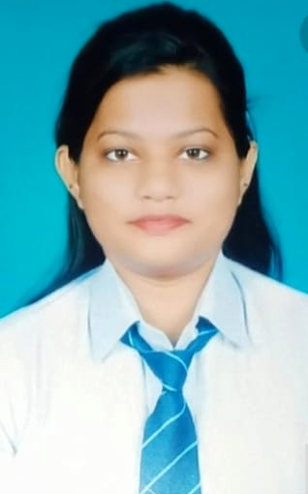
SEEMA KUMARI PASWAN
Address: Tulsipur, income tax colony
(Kafla market) Odisha,
Cuttack, 753002
Phone No- +91-7609845646
Email- seemapaswan9937@gmail.com

OBJECTIVE

- To grow as a skilled Finance professional excelling in Training & Development area in IT industry.

PROFESSIONAL SUMMARY
- An MBA in Finance with minor specialization in IT.
- Sound Knowledge on Financial statements analysis.

EDUCATIONAL QUALIFICALTION:

- 2021, MBA from USBM, Bhubaneswar in Finance & IT specialization.
- 2019, B.Com from Choudwar college under Utkal University, Odisha.
- 2016, 12th in Commerce stream from Choudwar College, Choudwar, under CHSE, Odisha .
- 2014, 10th from CBSE board , Kendriya Vidyalaya ARC Charbatia, Odisha

SUMMER INTERNSHIP

(1) Title: - FINANCIAL STATEMENTS WITH SPECIAL REFERENCE TO SOLVENCY RATIO
Company: - OPGC, BBSR
Learning Outcomes:
- Prepared documents needed to manage report selected by finance manager.
- Learnt how to prepare finance report.
- Attended financial seminar by senior officers.
- Gained Practical overview of daily Practices (work from home).

(2) Title: - TECHNICAL ANALYSIS OF FEW LEADING STOCK IN BANKING SECTOR
Company: - MOTILAL OSWAL
Learning Outcomes:
- Daily practices how on stock buy and sell in the market (through the online Apps).
- Attended stock seminar by seminar officers.
- Prepared document needs to implement plans selected by finance manager.

SEMINARS AND WORKSHOPS

- Innovation in the Indian financial markets IIMT, BBSR
- 1-day seminars on Business Economy USBM BBSR

CERTIFICATE PROGRAMME

- Done certificate course in PGDCA in computer operation
- Basic knowledge in Ms-word, Ms-PowerPoint, Ms- Excel and tally .

AWARDS & RECOGNITION

- Awarded Best Painter award in eastern zone by Govt. of Odisha (2017).

EXTRA CURRICULAR ACTIVITIES

- Event organizer of school and College Annual Function.
- Athletic champion in inter school competition (2017)

PERSONAL SKILLS
- Ability to work enthusiastically in team and good communicator.
- Ability to grasp, positive thinking.
- Fast learner, can undertake challenging tasks.

GENERAL INTERESTS

- Painting
- Plantation
- Cooking
- Listening Music
- Solving Puzzles

PERSONAL PROFILE

- Fathers Name : Mr. Sharwan Kumar Paswan.
- Mothers Name : Mrs. Manju Devi.
- Date of Birth : 31.01.1999
- Gender : Female
- Nationality : Indian
- Religion : Hindu
- Marital Status : Single
- Conversant in : English, Hindi and Oriya

DECLARATION

I hereby declare that all the above-furnished information is true to the best of my knowledge and I will be held responsible for any deviation from them at a later stage.

Date:
Place: Cuttack

