JOHNSON MBUOTIDEM

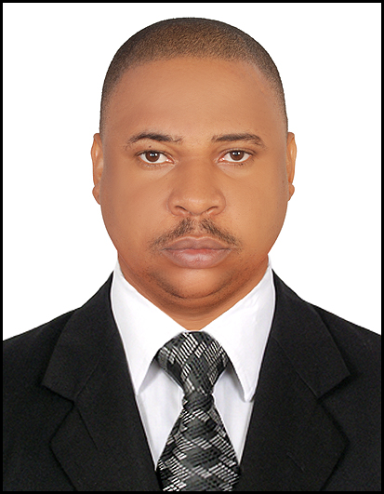
Address : Flat 501, Diamond Building, Al Baraha, Dubai - U.A.E
Email : johnson.mbuotidem@gmail.com
Marital : Married
Passport : A02267733 Mobile: 0528941005
Sex : Male
D.O.B : 12th, February 1977
Country : Nigeria

PROFILE.
Persuasive, inclined towards the communication of ideas, excellent interpersonal skills and a well tuned analytical mind, capable of using own initiative as well as working in a team frame work.
Committed, smart and hardworking, aiming to utilize my potentials to further develop my self- management and work- content skills in a reputable organization with opportunities for professional development, new challenges and responsibilities.

PERSONAL ATTRIBUTE
Proactive, intelligent, flair for excellence, attentive to details, warm and personable, a seasoned musician with the ability to play the drum set.
PROFESSIONAL EXPERIENCE
ACTOLOG LIMITRED-November 2012-December 2015
Customer Care Specialist (Inbound).
- Handling calls from new and existing customers regarding a variety of requests.
address issues, provide support and offer information, as needed, to keep customers satisfied and retain business
- Attracts potential customers by answering product and service questions; suggesting information about other products and services.
- Opens customer accounts by recording account information.
- Maintains customer records by updating account information.
MOUKA LIMITED- May 2010-March 2011.
Inbound sales agent
- Receives calls from customers who want to buy our products.
- Cross- sell product.
- Resolves product or service problems by clarifying the customer’s complaint, determining the cause of the problem, expediting correction or adjustment following up to ensure resolution.

VCONNECT.COM- April 2008 – January 2010.
Inbound retention representative.
• Working exclusively with existing customers.
• Responsible for ensuring customer satisfaction and retaining business.
• Following established procedures and guidelines
• Address problems and complaints, suggest solution and drive positive outcomes.

SOVEREIGN TRUST INSURANCE PLC- Feb. 2004 - Oct. 2007.
Customer Care.
• Listen and respond to customers’ needs and concerns
• Provide information about products and services
• Take orders, determine charges, and oversee billing or payments
• Review or make changes to customer accounts
• Handle returns or complaints
• Record details of customer contacts and actions taken
• Research answers or solutions as needed
• Refer customers to supervisors, managers, or others who can help.

WORK SKILLS
- Office Automation, proficient in Microsoft Word Environment, Excel, Power Point Presentation.
- Able to deal courteously with people on first contact, handle clients concerns and complaints.
- Provide correct answers to clients’ question and enlightenment on services required.
- Motivated to apply quick thinking to the ‘big pictures’ through holistic ideas, concepts, options and strategies.
- Ability to accept and exercise responsibility, device strategies towards meeting organizational goals.
- Mentally equipped for trouble shooting with prompt and intelligent solutions.
- Quick and eager to learn, take corrections, open minded and curious.

EDUCATIONAL QUALIFICATION.
- University of Lagos 2005.
B.sc (Hons) Chemistry.
- Oshodi Secondary School, Apapa, Lagos (O’ level GCE/Senior School Certificate). 1995.
- St.Johns Anglican Primary School, Araromi-Apapa, Lagos. (FSLC) 1990.

HOBBIES
Table and Lawn Tennis, Football, Reading Self-Improvement books. Playing of Musical Instrument (Drums).
REFERENCES
Available on request.

