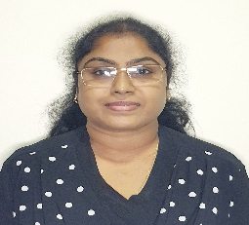

**Curriculum Vitae**

**Contact: 055-4177583 & 058-6502365**

**Email: hemamalini.edu@gmail.com**

Name : Hema Malini

Nationality : Indian

Date of Birth : 26-05-1972

Visa Status : Visiting Visa

Passport No. : S 8979145

Valid till : 07-11-2028

Languages Known : English, Hindi & Malayalam

Computer Proficiency : MS Office, Word, Excel & Internet

**Qualification**

* Master Degree in Commerce & Accountancy from University of Calicut, Kerala. India.
* Post Graduate Diploma in Computer Application from Info Educational Group, Kerala.
* Post Graduate Diploma in Information Technology from Kerala IT Mission, India.

**Work Experience**

* 2 years Worked as a Consultant & Administrative officer at Bharthiya Vidhya Bhavan Trichur, Kerala. India.
* 5 years worked as a Students Coordinator with Administrative Assistant at St. Mary’s UPS Lourdes at Trichur, Kerala. India.

**Job Responsibilities**

* Assist in designing curriculum plans to promote student learning, stimulate class discussions and student engagement.
* Evaluating student progress by ensuring fair and effective assessment procedures.
* Prepare reports and presentations.
* Planning, organizing and executing departmental meetings, seminars and conferences.
* Provide appropriate feedback on work and students report to the Head of Department and Management.
* Maintain accurate and complete records of students’ progress and developments.

**Key Interesting Areas**

Administration, Reading, Travelling, Motivating & Counselling.

Sincerely,

Hema Malini