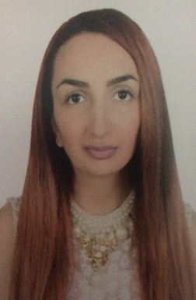 |  | Ani Araskhanyan  Customer service officer
Profile  Seeking a challenging career with a progressive organization  Which will utilize my skills, abilities and education. An ambitious and focused individual, who  Is self-motivated, enjoys hard work and being challenged. Enthusiastic and passionate within work, eager to learn and take on new skills. Professionally presented with polite and friendly mannerism.  Contact  PHONE:  0097154-559-1125  WEBSITE:  Adecco.AniA@nakheel.com  EMAIL:  Inaharmon98@icloud.com  Hobbies  1.Languages  2.Swimming  3.IT programs  4.Multitasking |  | EDUCATION  School of Victor Hambardzumyan  Abovyan, Armenia  01/09/2006 – 25/05/2014  Eurasia International University  Yerevan, Armenia  01/09/2014 – 25/05/2017  Eurasia international university is an institution of higher professional education.  WORK EXPERIENCE  Nakheel -Customer service officer  Dubai, UAE -09/2018–Present  Nakheel’s current and future retail project portfolio covers 17 million square feet of leasable space. Customer service role is really important as we are the face of the company, starting with grooming standards, body language and the best provided service to our customers.  ABZ Beliy Rast -Reception/ Front desk  Dmitrov region, Moscow -08/2017–05/2018  The company is distributing sales of consumer goods for building purpose. Reporting to manager and being part of very big team, I was responsible for gathering data and accepting orders from 45+ companies, dealing with all types of customers and documentations.  Fillion -Customer service  Moscow, Bagrationovsky Proezd -02/2016-02/2017  FILION is one of the largest shopping centers for the whole family in Moscow, a convenient place for shopping and recreation. Being a part time intern while studying on distance the experience working as customer service was very rewarding with new knowledge and skills.  SKILLS- languages and computer

