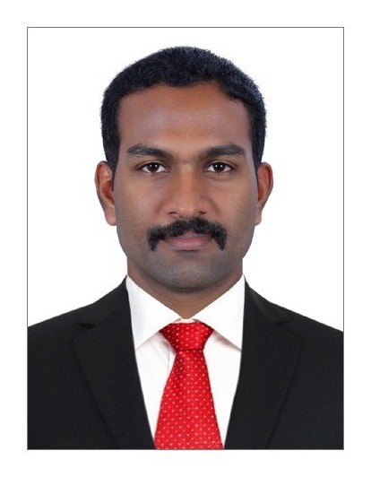**Resume**

Sijo Sabu

+917306046129

[sijosabu94@gmail.com](mailto:sijosabu94@gmail.com)

# Customer Service Vacancy

# Career Objective:

To be a successful professional by associating myself with an organization where there is an opportunity to share, contribute and upgrade my knowledge for the development of self and the organization and thereby build a career which will help me to explore myself fully and realize potential.

# Educational Qualifications:

|  |  |  |  |  |  |
| --- | --- | --- | --- | --- | --- |
| No. | EXAMINATION | COLLEGE | YEAR | BOARD / UNIVERSITY | % |
| 1 | BCA (Bachelor of Computer Applications) | Siena College of Professional Studies, Edacochin, Kerala, India | 2015 | Mahatma Gandhi University, Kottayam, Kerala, India | 44.75 |
| 2 | 12th | Holy Family Higher Secondary School, Muttom, Cherthala, Kerala, India | 2012 | Board of Higher Secondary Examination, Kerala, India | 74 |
| 3 | 10th | St. Ann’s Public School, Cherthala, Kerala, India | 2010 | Council for the Indian School Certificate Examinations, New Delhi, India | 72.42 |

# Other Course:

|  |  |  |  |  |  |
| --- | --- | --- | --- | --- | --- |
| No. | EXAMINATION | COLLEGE | YEAR | BOARD / UNIVERSITY | % |
| 1 | Diploma in Aviation Hospitality & Airline Management | Victoria Academy for Aviation Studies, Ernakulam, Kerala, India | 2016 | Scientific and Technical Education Development (STED) Council, Trivandrum, Kerala, India | 72.25 |

# Other Certificates:

|  |  |  |  |  |  |
| --- | --- | --- | --- | --- | --- |
| No. | EXAMINATION | BOARD / UNIVERSITY | YEAR | TEST RESULTS | OVERALL BAND SCORE |
| 1 | International English Language Testing System (IELTS General Training) | British Council | 2019 | Listening-6.5  Reading-6.5  Writing- 6.5  Speaking-6.0 | 6.5 |

|  |
| --- |
| **Personal Details:** |

Father’s Name : Sabu

Mother’s Name : Liziamma Augustine

Gender : Male

Date of Birth : 12-10-1994

Marital Status : Single

Nationality : Indian

Blood Group : A+

Religion : Christian

Height : 158cm

Passport No. : N6116369

Pan Card No. : JDKPS4631F

Languages Known : English, Malayalam

Hobbies : Travelling, Fishing, Playing Football

Permanent Address : Pallikkara House, CMC-4, Nedumbrakad,

Cherthala P.O-688524, Alappuzha District, Kerala State, India

I hereby declare that the above information is true and correct to the best of my knowledge and belief.

Date: 22-08-2021 (Sijo Sabu)