M.MUDASSAR SIDDIQUE KHAN  Mobile: +966594669430 - +923315085028  E-mail: M.MUDASSAR078@GMAIL.COM  Address: House # 34 New ChakMadad Khan Rahim Town Westridge 2 Rawalpindi. | 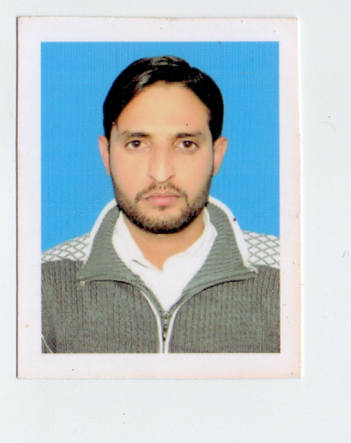
To work in a challenging environment where I have the opportunity to facilitate people by providing them services using my analytical and technical skills. Want to work with energetic and sharp professionals having strong vision and knowledge in their domain

PERSONAL DETAILS

Father’s Name: Muhammad Siddique Khan
Date of Birth: 09th April 1986
Nationality: Pakistani
CNIC: 37405-8428824-1
Religion: Muslim
Marital Status: Married
EDUCATION
Secondary School Certificate (SSC).
Punjab Board of Intermediate & Secondary Educations, Rawalpindi, Pakistan.
PROFESSIONAL DIPLOMA / CERTIFICATE

Civil Surveyor 6 Months. 2007
Federal Board Islamabad
Auto Cad 2 Years. 2009
Panjab Board.

PC SKILLS

- MS Office (Word, Excel & PowerPoint), Internet and E-mail Applications.
- Windows Operating Systems.
- English Typing Speed 45/ W.P.M
LANGUAGES
- English
- Arabic
- Urdu
- Panjabi

Experience

PGI DESIGN GROUP BLUE AREA ISLAMABAD
DESIGNATION CAD OPERATOR
DURATION Jan 2010 to Jan 2014

Duties & Responsibilities:-

Prepared presentation & working drawings.

REFRANCENCE

Architects: Asad Ashfaq –Azhar Mahmood Qureshi

Office 051-2273857
Fax 051-2270653

BAHRIA TOWN PVT LTD
DESIGNATION CAD OPERATOR
DURATION Jan 2014 to April 2015
Duties & Responsibilities:-
Prepared presentation, working drawings & Site inspection of Bahria Enclave Islamabad.
REFRANCENCE
Bahria Enclave-I design wing Bahria Town (PVT) Office 051-2721004
Architect Mujahid Hussain Cell 0092-3336681897

BIN JARALLAH HOLDING COPANY FOR TRADING & CONTRACTING (KSA)
DESIGNATION CAD OPERATOR
DURATION march 2015 to Till…

Duties & Responsibilities:-
Prepared presentation & working drawings.
Preparing Shop Drawings, Road profiles And Working at Sewerage & Storm water Pipe Layout & manhole. Potable & Irrigation Water Pipe layout, Open Chanel & Culvert work.
Project of the ministry of Hosing in the Kingdom Of Saudi Arabia Preparing Work Inspection Report (WIR) Working on PCM (Primavera Contract Manager)

REFRANCENCE

ENGEERS: Mr.YOUSAF – Mr.ALI FOUZY

Office address: Riyadh 11472 P.o. Box 7577 Kingdom of Saudi Arabia.

