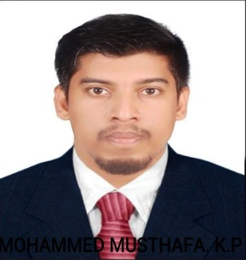  MOHAMMED MUSTHAFA  E-MAIL:  musthafamuhammed260@gmail.com  CONTACT:+919633555479,  +917907166803  PERMENANT ADDRESS  S/o Mohammed Ali  Kalliparambil House,  Kunnappally Post,  Malappuarm  Pin –679322  Personal Details  Date of Birth :17.8.1994  Religion : Islam  Marital Status :Single  Nationality : Indian  Blood Group : A+ve  Linguistic Abilities  To Read & Write  English, Malayalam, Hindi &Arabic  To Speak  English, Malayalam ,  Hindi& Arabic | CAREER OBJECTIVE  To work in a firm with professional work driven environment where I can utilize and apply my knowledge, skill which would enable me as a fresh graduate to grow while fulfilling organization goals.  EDUCATIONAL QUALIFICATION  - B.com (Calicut University)  - Plus Two, Humanities(Board of Kerala)  - SSLC (Board of Kerala  TECHNICAL QUALIFICATION  Tally  Peachtree  excel  WORKING EXPERIENCE  - CASH SUPERVISOR IN AJMAL BISMI ENTERPRISES  16th NOV 2018 till continue.  - CASHIER CUM SALESMAN AT SPORTS LAND  01ST JAN 2017 TO 01st OCT 2018  - MARKETING EXICUTIVE AT IMAGIN WORLD(JOB  CONSALTANCY) 03rd FEB 2015 TO 29TH DEC 2016  PASSPORT DETAILS  Passport No :P3695933  Date of Issue :10/11/2016  Date of Expiry :09/11/2026  Declaration  I here by declare that the above-mentioned information is correct up to my knowledge and I bear the responsibility for the correctness of the above mentioned particulars  Place : Kunnappally MUHAMMED MUSTHAFA  Date :

