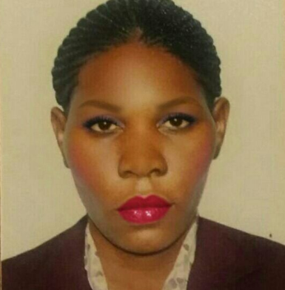

**Nabagereka Florence**

**Shabiya ME-10, Mussafah,**

**ABUDHABI**

[**nabagerekaflorence2018@gmail.com**](mailto:nabagerekaflorence2018@gmail.com)

**Cancelled Visa**

**Mobile: + 971522076723**.

**CAREER OBJECTIVE**

My career objective is to work with creativity and initiative to the uttermost, through team work and deliver my best in terms of output, with full readiness to adopt and also learn new skills in the dynamic economic environment.

**KEY COMPETENCES & SKILLS**

* Ability to work effectively under time pressure and for long and extended hours.
* Ability to multitask.
* A strong passion to ensure customer satisfaction.
* A good memory and an eye for details.
* A friendly, cheerful, and polite attitude**.**

**EMPLOYMENT HISTORY**

**ATHENS GEN.CONT.& GENERAL MANT. EST., Abu Dhabi UAE**

**Archives Clerk: April 2019 – April 2020**  
  
**NOOKS AND CRANNIESCLEANINGCOMPANY, Dubai UAE**   
**Housekeeper: April 2018 – April 2019**

**SERVE U COMPANY, Dubai, United Arab Emirates**  
**Gym attendant: December 2015 - April 2016**  
  
**SARACEN SECURITY INTERNATIONAL LTD**  
**Lady Guard: January 2013 – November 2014**

**DUTIES AND RESPONSIBILITIES**

* Regular sales calls & follow up with existing and potential key accounts to open new business opportunities and ensure client awareness on new promotions –packages offered by the company.
* Prospect new markets for arising sales volume. Manage up sell of the available products.
* Arrange and submit offers and agreements to the company clients.
* Maintain continuous follow- up of existing an Address: d potential clients, maintain their database
* Follow up with customers, develop strong relationships and rapports.
* Handle customer complaints, resolve issues and ascertain client satisfaction.
* Providing the customer with the satisfactory answer to their questions about the products on sale
* Receiving and placing of the orders
* Dusting and polishing furniture and fixtures.
* Maintaining a clean and sanitary gym area.
* Vacuuming and cleaning carpets and rugs.
* Clean lockers, clean marks off walls, light switches, sockets etc.
* Use chemicals safely and effectively as trained, using the correct chemicals for each job as per the cleaning schedule. Attend update training as required.
* Undertake such other duties as the site Manager may from time to time reasonably require.

.

**EDUCATION**

**2000 – 2003** Degree of Bachelor of Arts with Education, Ndejje University, Kampala, Uganda

**1998 – 1999** Uganda Advanced Certificate of Education**,** Kakungulu High School, Uganda

**1991–1997** Uganda Certificate of Education, Kayunga Senior Secondary School, Uganda

**INTERESTS AND HOBBIES**

Reading, listening, travelling and touring, meeting, making and interacting with all kinds of people and generally all hobbies that reflect a good personality.

**PERSONAL DETAILS**

**Name s:** Nabagereka Florence  
**Gender :** Female  
**Age :** 41 years  
**Weight :** 70kgs  
**Nationality :** Ugandan  
**Marital status :** Single

**REFEREES**

Upon Request.