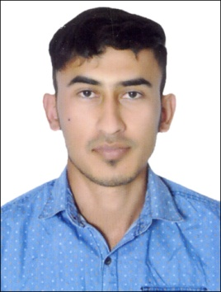CURRICULUM VITAE

**PRADIP THAPA**

**Contact: +971 567303523**

**Email:prdiipvaii143@gmail.com**

**APPLYING FOR MERCHANDISER**

**Objective:**

Pursue a career in a respectable organization, where I can utilize my experience and develop my service capabilities, to seek more challenging position that I am qualified to enhance my skill and learn new things that can be useful for my future for and for the company.

**PERSONAL DETAILS:**

***Date of Birth***  : 29-05-1997

***Nationality***  : Nepal

***Marital Status***  : Single

***Languages Known*** : English, Hindi and Nepali

**Passport Details:**

***Passport No*** : 09677906

Date of Issue : 28-03-2016

Date of Expire : 27-03-2026

**UAE Driving License Details:**

***License No*** : 3811749

Date of Issue : 07-04-2018

Date of Expire : 07-04-2024

Type of Vehicle : **Light Vehicle** (Automatic )

Lactation Knowledge : All UAE

**Professional Skills:**

* Excellent Working Ability
* Independently Motivated
* Quick to take initiative

**Educational Qualification:**

* Higher Secondary (12th )

**Computer Qualification:**

* Basic of computer

**Experience:**

* **Since last 1 year** working experience as a **Merchandiser** in **Nadec Dairy , Sharjah, UAE**
* **2 years** working experience as a **Delivery Boy** in **IBIS ALRIGGA, Dubai, UAE**

**Declaration:**

I hereby declare that all the statements made in the C.V are true to the best of my knowledge and belief.

**PRADIP THAPA**