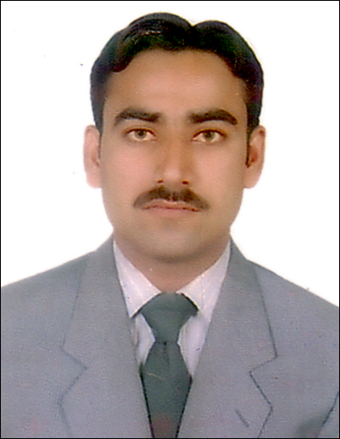

Muhammad Azeem
Khan Pur Rahimyar Punjab Pakistan.

Telephone: | +923456181790 & +923021398975
Email: | muhammadazeemace@gmail.com
Professional Profile
Accomplished, resourceful and versatile individual with a proven track record of providing technical solutions with challenging HVAC environments. Comprehensive knowledge of operation preventative and annual maintenance on commercial domestic chillers, AHU, FCU, FAHU, package units, and split and window A/C. Accurately performs challenging tasks with precision and attention to detail. An inspiring leader who is able to motivate others to achieve their potential and make a significant contribution to the delivery of common goals. Well organized too handle a variety of tasks and follow through from start to finish. Quick to grasp new ideas and concepts, possesses excellent time management, problem solving, decision making, listening and interpersonal skills. A self-starter and willing learner who thrives in challenging working environments.
Objective
I am now looking to secure a challenging and rewarding new role where I can apply the skills, knowledge and expertise I have gained throughout my successful career to date with further opportunities for professional growth.
Career Summary
Apr 2014 – Sep 2020 | HVAC TECHNICIAN, Sinyar Property Management (Royal Group), Abu Dhabi, UAE

Apr 2012 - Nov 2013 | HVAC TECHNICIAN, Al Wathba Company for Central Services, Abu Dhabi, UAE

Aug 2009 - Dec 2011 | HVAC SUPERVISOR, Carlton Hotel, Cool Equipment Engineering Karachi Pakistan

- Working effectively in HVAC teams providing a high quality preventative and annual maintenance service to customers on a broad range of Heating Ventilation Air Conditioning units
- Performing skilled mechanical maintenance duties in the inspection, repair, installation and alteration of HVAC and refrigeration systems and related equipment and facilities to strict quality standards
- Installing and repairing HVAC equipment, including refrigeration and air conditioning compressors, receivers, condensers, chillers, forced air converter units, pumps, automatic and hand valves and capillary tubes
- Working on a range of HVAC equipment, including commercial domestic chillers, AHU, FCU, package units, and Split and Window A/C.
- Conducting regular preventative maintenance inspections of refrigeration units, isolated heating and ventilating units, including boilers, gas and electrically operated air-conditioning equipment, and making required adjustments or repairs
- Repairing or replacing defective parts in units and equipment and their controls, including thermostats, automatic switches, fan controls, log switches, damper motors, louvers, relays, fitters, controls, belts, compressors, heat exchangers, high limit controls, pressure controls, safety valves, and automatic valves
- Lubricating and packing heating, ventilation, refrigeration, and air-conditioning motors, pumps, fans, and other equipment
- Installing, rebuilding, replacing or repairing fans, motors, thermostats, fuses, filters, bearings, valves, controls, gaskets and other equipment as necessary
- Installing and calibrating systems; installing copper tubing and repairing pipes and tubing as necessary; testing joints and insulating pipes of refrigeration and air conditioning systems; flushing boilers, descaling tubing; rebuilding pressure and temperature safety valves and water pumps
- Supervising and motivating technicians in the completion of workload by allocating tasks and monitoring performance to ensure they work to company and customer standards
- Working to strict health and safety guidelines and procedures at all times to ensure adherence to company and regulatory standards
- Providing effective assistance and support, and mentoring and training junior technicians, in handling daily tasks to ensure efficient management of workload
- Maintaining related records concerning time, labour and materials; maintaining log of tasks performed and writing accurate reports as required

IT Skills

MS Office: Word, Excel, PowerPoint, Internet, Outlook, Windows XP, Vista, 8

Education

August 2009 | 3 Year of Diploma Associated Engineer in Refrigeration & Air Conditioning (HVAC), First Division,
 | from Sindh Technical Board Pakistan
 | Matriculation from Karachi Board Pakistan
Personal Details
UAE Manual Valid Driving License.
Other: | Date of Birth: 08 January, 1985. Nationality: Pakistani. Civil Status: Married
Languages: | English, Urdu

References are available on request

