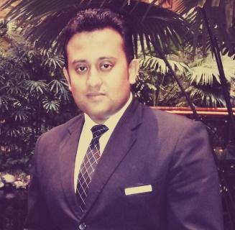

**MATHEW THOMAS**

**Home Address**

WZ 34/4, A, Singha Apts

Asalatpur, Janakpuri

New Delhi-110058

India

Email – [Mathew.is.there@gmail.com](mailto:Mathew.is.there@gmail.com)

Mobile –0091- 9911622477, 8920352425

**PROFESSIONAL PROFILE AND STRENGTHS**

* I am an enthusiastic and dedicated professional with extensive experience at aquisition in Sales domain.
* I can demonstrate a strong ability to manage projects from conception through to successful completion.
* A proactive individual with a logical approach to challenges, I perform effectively even within a highly pressurized working environment.
* Focused and hardworking, effective team player with excellent communication analytical and inter-personal skills.

**OBJECTIVE**

A role of a Sales Specialist with a focus on authentic experience with intent to target acquisition.

**PROFESSIONAL EXPERIENCE AND ACCOMPLISHMENTS**

* Presently working with Snowdrop Tours and Travel Chanakyapuri as Reservations Manager, (KRA being handling global bookings including Air Hotel Taxi and Tour packages, Handling a team of 7 FTH ) since August 2014.
* Worked with Grand Hyatt Dubai since March 2011 as Room Reservation Sales Executive and Sales Trainer (Promoted as Team Leader, Front Desk - on Aug 13) until the 08thJuly 2017
* Worked with WNS Global India as a Senior Travel Sales Agent from Sep09 till Dec 10
* Started off in Feb 2006, with GENPACT, Worked with GE Money and GE Supply as Process specialist in Collections COE (Centre of Excellence) Gurgaon and was designated as Process Developer and the Visual Management Rep of the Team .

**ACADEMIC AND PROFFESIONAL PROFILE:**

* 1 Year Diploma in Graphic Designing from Don Bosco Technical Institute.

**COMPUTER PROFICIENCY:**

* Extremely fluent with MS Office (Excellent in MS Excel)
* Sabre
* Net-Meeting
* Opera
* Reserve (Hyatt Internal Application)

**PERSONAL DETAILS**

Father’s Name – Mr. S Thomas

Date Of Birth - 22nd March 1985

Language Known- English, Hindi, Malayalam

Religion-Christian

Status - Married

I hereby declare that the above furnished information is true to the best of my knowledge and references are available on request.

Date Signature

04/10/2021 Mathew