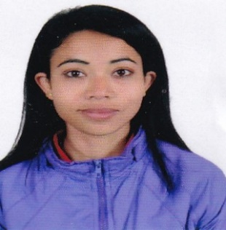**CurriculUm Vitae**

**BISHNU LIMBU**

**United Arab Emirates, Dubai.**

**Mob: +97150-4079564 (UAE)**

**Email: monumon440@gmail.com**

|  |
| --- |
| **OBJECTIVE** |

*A position with an organization where I can utilize the best of my skills and abilities that fit to my education, skills and experience a place where an encourage and permitted to be an active participant as well vital contribute on development of the company.*

**Skills:-**

* Efficient and well behaved person
* Very Energetic result oriented and organized
* Ability to work well in terms
* Fast adaptive learner with excellent power to learn

|  |
| --- |
| **EDUCATIONAL QUALIFICATIONS** |

* 10th and Basic computer knowledge

|  |
| --- |
| **WORK EXPERIENCE** |

* Worked as 18 month experience warehouse **AMD Company** in malaysia.
* Worked as 18 month experience **Ginco Solar** in Malaysia.
* Worked as 18 month experience **Lulu hypermarket** all round work in Qatar
* Worked as 18 month experience cleaner **American international school** in Qatar

|  |
| --- |
| **PERSONAL INFORMATION** |

Nationality : Nepal

Date of Birth : 12/02/1993

Gender : Female

Marital Status : Married

Language Known : English,Hindi,Nepali

|  |
| --- |
| **PASSPORT DETAILS** |

Passport No : 06060169

Date of Issue : 17/08/2012

Date of Expiry ; 16/08/2022

Visa Status : Cancel visa

|  |
| --- |
| **CHARACTER REFERENCE** |

Available upon request

I hereby and certify that the above mentioned is true and correct to the best of my knowledge and belief.

**BISHNU LIMBU**