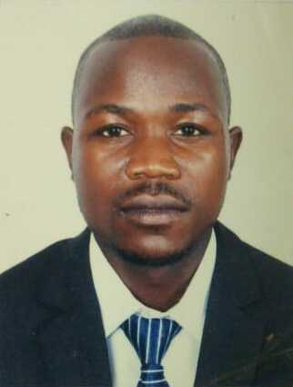NAME: MUTAMA MOSES

Tel: +971 503782110

Mob: +971 557806016

Email: [mutamamoses@gmail.com](mailto:mutamamoses@gmail.com)

**EDUCATION**

* Diploma special Education Needs and Disability at National Academy Dubai
* Attained Grade Three Teachers Certificate in 2009 at Kyambogo University Uganda
* Attained Secondary level and got Uganda Certificate of Education in 2007 at Nyondo Secondary school
* Sat for Primary Leaving Examinations and attained Primary Leaving Certificate in 2003 Primary at Nyondo Demonstration School

**EDUCATION**

* Worked at Elgon Junior School in Mbale from 2010 to 2015 as a class teacher primary class, Teaching English Language in primary six and seven
* Worked at Bijaaba Primary School from 2016 to 2017 as a class Teacher, sports and games master. Trained students and managed to secure a trophy at zone level.
* Works as a Mason general at Concord stars contracting L.L.C Dubai UAE.

**SKILLS AND ABILITIES**

* Fluent in English speaking
* Best in leadership skills
* Ability to handle leaners with special needs and disabilities
* Best in co-curricular activities
* Shows professionalism at work
* Cheerful, Enthusiastic and Innovative
* Aspiring, Hardworking and Dedicated in nature
* Able to work well in a team
* Perform assigned tasks with greater responsibility
* Friendly and pleasuring in nature
* Able to meet deadlines
* Good communication and interpersonal skills
* Eye for detail
* Proficient in the computer
* Goal Oriented
* Ability to motivate the learners
* Ability to enhance methods and techniques while handling learners

**REFERENCES**

1. National Academy Dubai UAE
2. Head teacher Bijaaba Islam Primary School Uganda (+256 70111070)
3. B.Ed in Special Education, Therapist, Childhood Care Education Specialist UAE (+971 504462256)

Personal Details:

Gender: Male

Nationality: Ugandan

Language: English and Swahili

Passport No: B1726056

Marital status: Married

Address: Emirates Road Al khawaneeji-2 Dubai UAE