SAJAD HAMZA  Mob. : +91-9567952737  Email : sajadrh@gmail.com | 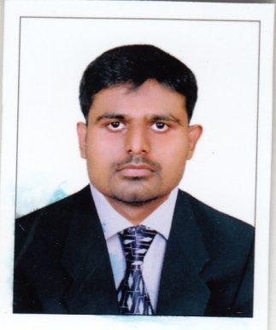
Career Objective
Seeking a challenging position in a progressive organization with an aim to contribute positively towards the objectives of the organization to the best of my capabilities to develop my professional skills.
Personal Details:  Date of Birth : 09/07/1987  Father’s name :Hamza  Sex : Male  Religion : Islam  Nationality : Indian  Marital Status : Single  Permanent Address:  Rayamarakkar House  Palayoor Road  Muthuvattoor  P.O.Chavakkad-680 506  Languages Known:  English : (Read, Write, Speak)  Hindi : (Read, Write, Speak)  Malayalam : (Read, Write, Speak)  Tamil : (Speak)  Arabic : (Read, write)  Interests :  Interacting with People  Passport Details:  NO: H0286902 | Educational History  MBA, Finance & IT  National Institute of Management studies － Cochin, Kerala, India (80%) 2012  Graduate Diploma in Business Administration  National Institute of Management studies － Cochin, Kerala, India (70%) 2009  PLUS TWO, Commerce  Board Examination － Thrissur, Kerala, India (65%) 2006  Other Technical Education  Diploma in Hardware & Networking (MCSE,CCNA)  Accel IT Academy Thrissur, 2010  Professional Work Experience  Organization: Classic Paint Rollers & Allied Products  Designation: Manager  Duration: January 2011- Present  Roles & Responsibilities.  - Driving and delivering the commercial performance of the business,  - Scheduling workloads to meet priorities and targets  - Setting recruitment, appraisal and line management processes  - Implementing business procedures  - Organizing staff schedules & maintenance of equipment  - Ensuring that company goals are met in a timely fashion by the efficient and effective management of personnel and resources  - Working with other department heads  - In charge of all departmental procurements  - Undertaking staff performance reviews  - Maintain a proper filing system for Finance & Accounting Department  - Establishing the businesses objectives  - Involved in the recruitment and mentoring of new staff ,  Achievement  Promoted from Assistant Manager to Manager
Academic Project/Seminars/Workshop

- A study on Impact of Stress level on productivity with Special reference to” Classic Decorative Tools &
Allied Products Kanippayyur”

Technical Knowledge
Operating Systems: Windows X.P,7,8
Software’s : Microsoft Office, Tally ERP 9, Advanced EXCEL,

Achievements and Positions of responsibility

- Time bound performance

- Team work and leadership quality

- Good communicational and interpersonal skills

- Expertise in Finance& IT skills

Declaration

I hereby declare that the above mentioned information is true to the best of my knowledge.

With Respect,
Place:- Thrissur

Date :-
SAJAD HAMZA

