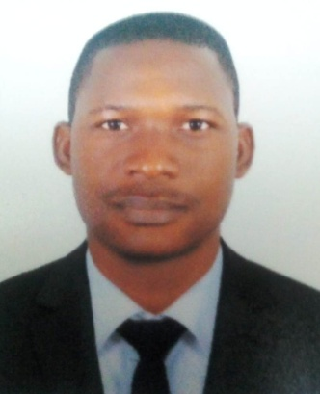Olaoye Anthony Sesan

7 street Al hamriya big mosque, Abu Hail. Dubai

(+971)586894346,(+234)7069080352

sesananthony24@gmail.com

**APPLICATION FOR THE POST OF A HELPER**

**PERSONAL DATE**

Sex : Male

Marital status : Married

Date of Birth : 15th January, 1988

Home town : Imode

L. G.A : Oke-ERO

State of Origin. : Kwara State

Nationality : Nigerian

Religion : Christianity

Visa Status. : Employment visa ( Cancelled)

**PERSONAL ATTRIBUTE**

* A self proficient and assiduous personality
* A good and drive to achieving positive result in a given target
* To develop a professional career in a dynamic organization that allows for growth
* Be in position or responsibility and offer meaningful contribution in achieving the adjectives of the organization

**HOBBIES AND INTEREST**

Reading, engaging in constructive discussion, watching films, traveling and sports

**EDUCATIONAL INSTITUTIONS ATTENDED WITH DATE**

* Kwara State polytechnic, Ilorin (HND) 2007-2010
* Kwara State polytechnic, Ilorin (OND) 2001-2004
* Buhari Comprehensive High School, Buhari (SSCE) 1994-2000

**CERTIFICATE OBTAINED WITH DATE**

* Higher National Diploma in Business Administration 2007-2010
* Diploma in Computer Studies (Ms words and Ms Excel) 2003 -2004
* National Diploma in Business Administration 2001-2004
* Senior Secondary School Certificate (SSCE-NECO) 1994-2000

**WORKING EXPERIENCED WTH DATE**

**ORGANIZATION:. Chez Michel Restaurant world Trade center dubai**

**POST HELD. :. Waiter July. 2019 till date**

ORGANIZATION: Con-Oil Nigeria plc. Ilorin

POST HELD: Office Assistance 2015-2018

ORGANIZATION : Texaco oil Nigeria Plc

POST HELD:. Office Clark 2012-2015

ORGANIZATION: Construction Products Nigeria Ltd

POST HELD: Store keeper 2009-2012

**MY DUTIES UNDER OFFICE ADMINISTRATOR**

**Performing the administrative duties,such as implementing office fill-in system,handling files and papers, greeting visitors, disseminating information through telephone and other means, managing appointment and meetings and performing any other assignments that arise**

**REFEREES**

ENGINEER ADEGOKE SUNDAY

Fish Round about Area Dubai

0522774146

**KEKINDE ISREAL OLUSHOLA**

i/cDecrown (W.A) co. Ltd

No. 6 suma close Aro Drive, Abuja

+2348034773346