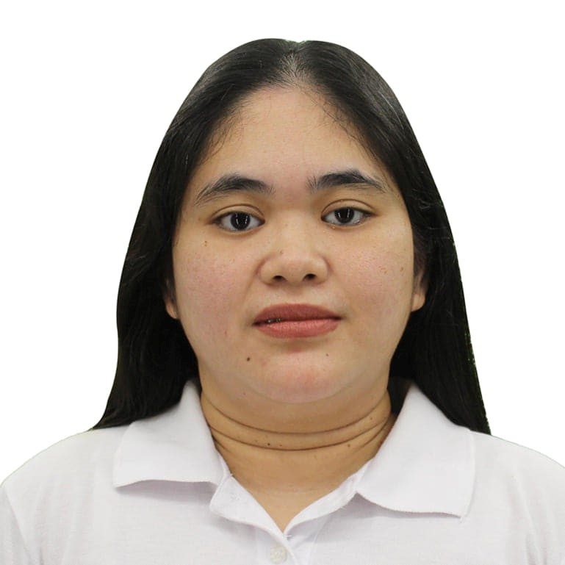 |  |  |  | Angelique Rose  Fragada

Experience
IMA GENERICS DRUGSTORE
Manila, Philippines
March 2021–July 2022
PHARMACY ASSISTANT
- Refer to prescriptions to the pharmacy.
- Assist in the preparation of medicines.
- Select stock and attach dispensing and cautionary labels.
- Put medication into administration containers.
- Use computers for routine maintenance procedures.
- Carry out customer service duties, such as answering enquiries and advising customers on appropriate products for use in relation to certain health related conditions.
- Operate cash registers.

Education
UNCIANO COLLEGES INC
Antipolo, City Philippines.
- Degree: B.S. Nursing (Undergrad)
TRAITS/SKILLS:
- A good listener, observant, and enthusiastic
- Hard working and trustworthy
- Have a good communication skill
- The ability to read and carry out instructions
- Pay attention to detail
- Computer Literate
- Willing to be trained
- Can work under pressure
Personal Data:
Date of Birth: August 07, 1989
Age : 33 yrs. Old
Height : 4’10”
Visa Status: Visit Visa
Languages: English and Tagalog
307 Al Masaken Bldg.
Muraqabat Deira, Dubai.
 |  | +971 585338003
 |  | Fragadaangeliquerose07@yahoo.com
CAREER OBJECTIVES:
- I want to gain knowledge and to have more experience in all aspects of this job.
- I want to work in a service oriented company wherein I could hone my skills and develop what I learned from school through hands on experience.
- To adapt and put into practice what I have learned in my previous years of studies.
- Seeking a position as Pharmacy Assistant.

