**NIMISHA RAJAN**

Address :“Chakkalayil House”, Naranmmoozhy Post, Madanthamon, Athikkayyam, Pathanamthitta Dist., Kerala - 689711.

Mob: +91 9562211642

E-mail : [nimisharajan1023@gmail.com](mailto:nimisharajan1023@gmail.com)

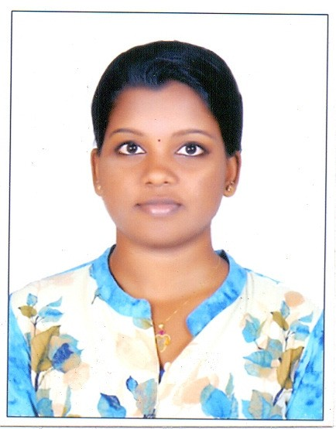**OBJECTIVE**

To work for an organization that can enhance my skills in the field of Computer Science and Programming and master the techniques of Software programmers. My ambition to be part of a major segment in the field of Computer Science.

**EDUCATION**

**Computer Science and Engineering**

**2015-2019**

James College of Engineering & Technology. Nagarcoil, Tamil Nadu. First Class

**Higher Secondary - GHSS Kadumeenchira 2013-2015**

Percentage of Marks : 72%

**SSLC - GHSS Kadumeenchira March 2013**

Percentage of Marks : 70%

**AWARDS & ACHIEVEMENTS**

Coordination Certificate in College Expo

**EMPLOYMENT RECORDS**

Software trainee in JAVA & HTML at Indian Dreams Technologies, Bangalore.

**MAIN PROJECT**

**TOPIC - Compromised User Behavior on Social Network.**

Compromising social network accounts has become a profitable course of action for cybercriminals by hijacking control of an popular media or business account.

**MINI PROJECT**

**TOPIC – Li-Fi Technology.**

Li-Fi is a wireless optical networking technology that uses light-emitting diodes for data transmission.

**INDUSTRIAL VISIT**

**1. SEAVIEW SUPPORT SYSTEM PVT. LTD. at Trivandrum**

**TECHNICAL SKILLS**

Dot Net

SQL

C++

JAVA

C Programming.

HTML

**HOBBIES AND INTERESTS**

Listening Music,

Watching Movies

Travelling

Cooking, reading, teaching

**PERSONAL DETAILS**

AGE : 21 YRS DATE OF BIRTH : 23-09-1997

GENDER : Female Nationality : Indian Religion : Hindu Marital Status : Single

Languages : English , Malayalam , hindi . Aadhar No. : 6450-9157-4167

PAN No. : BZWPR5862F

**DECLARATION**

I solemnly declare that the facts furnished above are true to the best of my knowledge and belief.

**NIMISHA RAJAN**

Place : Date :