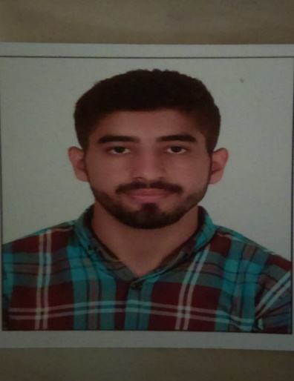**Saqib Khan**

WhatsApp # 00(971) -55 75 91 013

Call # 055 75 91 013

**Saqibsksk.1010@gmail.com**

**Home Address**: Street Molvi Abdul Hakeem, Chowk Gari Khana, Inside Lahori Gate, Peshawar City-KP-Pakistan

**Current Location:** United Arab Emirates, Al Qouz 2, Villa 71

**Nationality**: Pakistani

**Visa Status: File Clerk**

**Visa Duration**: till (15th January 2022)

**Marital Status**: Single

**Emirates ID:** 784-1998-8050309-1

**Driving License:** 4065883

**Date of Birth**: 19, July, 1998

OBJECTIVE

* Trained defensive driver
* Experience driving various vehicles, such as private cars
* Exceptional customer service skills
* Clean-cut, well-dressed appearance
* Ability to read, write, and communicate effectively in English
* Punctual and able to work a flexible schedule
* Working knowledge of GPS and smartphone applications for navigational purposes
* In-depth geographical and route knowledge

ACADEMIC QUALIFICATIONS

**F.Sc. Pre Engineering**

**(Mathematics, Chemistry, English)**

Iqra College, Peshawar

**Matric (Science)**

**(Mathematics, Physics, English)**

Senior Cambridge Public School, Peshawar

Experience (1, Year)

|  |  |
| --- | --- |
| Company | Working As |
| Me and My tourism | File Clerk |