*****************************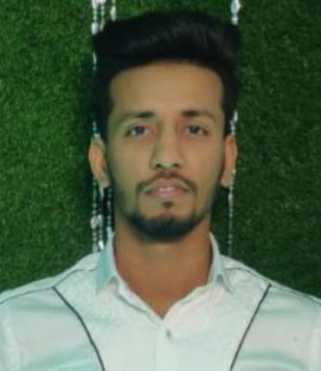***§cur r icul um vit a e**

**SHAIKH YASEEN MEHMOOD**

Building no :08

Flat no : 110

China cluter

Dubai international City

**Contact No**:+971 569487754

**Passport no : U8598690**

**Email-Id**: shaikhya08@gmail.com

**OBJECTIVE**

 To secure a responsible career opportunity to fully utilize my training and skills while

making a significant contribution to the success of the company.

 To enhance my educational and professional skills in a stable and dynamic workplace.

**WORK EXPERIENCE :-4**

**Organization** **: TELEPERFORMENCE Pvt Ltd**

**Post Held**: Customer Service Associate

**Tenure:** 16Aug 2020 To April 2021 Till Date

**Job Profile**

 ICICI Direct related to share market. Where I used to tell customer to come online with

the help of mobile or laptop .Then I used to guide them how they can start their first

investment. Then customer used to come online.

 First of all customer used to login then he/she has to add his/her funds from his saving

bank to trading A/c. Once the payment part has done. Then I used to put forth ICICI direct

recommendation. Then customer use to recognized it and choose one stock. Then he/she

can placed the order.

**WORK EXPERIENCE :-3**

**Organization** **: TELEPERFORMENCE Pvt Ltd**

**Post Held**: Customer Service Associate

**Tenure:** 10 February, 2020 To 15 August, 2020

********************Job Profile:**

 I had worked with Kotak Mahindra process

 Where I used to sale Term insurance to the customer.

 Due to Ram down of the process later move on to ICICI Prudential Insurance process

**WORK EXPERIENCE :-2**

**Organization** **: TELEPERFORMENCE Pvt Ltd**

**Post Held** **:** Customer Service Associate

**Tenure:** 13 Feb2019 To 30 July 2019

**Job Profile:**

 I had worked with ICICI Prudential Insurance process.

 Where I used to sale Term insurance to the customer.

 Due to Ram down of the process later move on to ICICI Prudential Insurance process

**WORK EXPERIENCE :-1**

**Organization** **: TELEPERFORMENCE Pvt Ltd**

**Post Held** **:** Customer Service Associate

**Tenure:** 10 May2018 To 12 Feb 2019

**Job Profile:**

 I had worked with L.G (Lead Generation) process.

 Where I used to sale Credit card to the customer.

 Due to Ram down of the process later move on to ICICI Prudential Insurance process

**QUALIFICIATION**

 Appeared for F.Y.B.Com from YashwantRao Chavan Maharashtra Open University

(correspondence)

 H.S.C. Passed in November 2017 - 2018 -– II Class

 S.S.C. Passed in March 2013 - 2014 –-With Distinction

********************OTHER QULIFICATION**

 Completed a course of  **MS – CIT**

 Completed course of **Tally Accounting Financial program**

 Completed cource of **Advanced excel**

**PERSONAL DETAILS**

 Name : Shaikh Yaseen Mehmood

 Date of Birth : 25th 0ctober,1998

 Height :

 Marital status : Single

 Nationality : Indian.

 Religion : Islam

 Languages known : English, Urdu

 Hobbies : Playing Cricket, listening music,

**DECLARATION**

 I hereby declare that the information furnished above that is true to the best of my ability &

knowledge.

**SHAIKH YASEEN MEHMOOD**

**DATE:-**

**PLACE:-DUBAI**