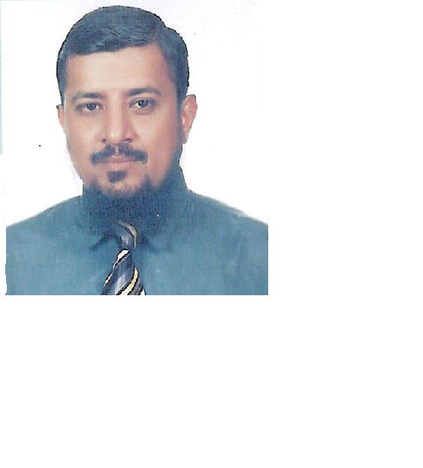
Name: Mahmood Hussain
Address: 2/587, Shah Faisal Colony
Karachi, Pakistan
Telephone nr: +923002234864 (mobile)
Birth date: 02 April 1965
E-mail: mahmoodhussain774@yahoo.com
Pharmaceutical Sales Representative
Ambitious, versatile professional with admirable career achievements and success
Professional Objective:
I am seeking to further my career as sales account manager in an international organization that requires an energetic, innovative sales person to improve the overall sales performance and to maintain the total concept of personal and professional service.
Professional strengths :
Customer Acquisition Strategies Mentor and motivator Marketing skills
Professional Presentation Customer relationship building Business management
Negotiation tactics Contract Negotiations Medical terminology
Key account management Team builder pricing proposals
Market and competitive Analyst Account &Territory management

Professional Experience:

November 2001 – Present : High-Q-Pharmaceutical (Pvt) Ltd.
Area Sales Manager
10, 5 years of sales experience, including national key accounts management, product launches and territory management.
Team leader sales and marketing team.
Develop and manage promotional activities
Setting company and team goals.
Training of sales team.
Motivating sales team to achieve goal.
Promote use of and sell drugs and other pharmaceutical products.

February 1994 – October 2001: LEK Pharma Pakistan
Sales Promotions Officer
Identifying and establishing new leads and business.
Organizing workshops with community and hospital based healthcare staff.
Negotiating contracts.
Demonstrating / presenting products to healthcare staff.
Demonstrating products to Doctors nurses and Pharmacist.
Market research.
Budget responsible.

December 1992- January 1994: Ankaz Pharmaceuticals

Technical writer

Writing technical literature
Negotiating contracts
Marketing research
Demonstrating products to healthcare staff, doctors nurses and pharmacists.

Education:
February 1992: | Karachi University, Karachi  Bachelor of Arts.
June 1988: | Sindh Board of Education, Karachi  Intermediate.
July1985: | Sindh Board of Education, Karachi  Metric.
Languages:
Urdu Mother language
English 2nd Language

