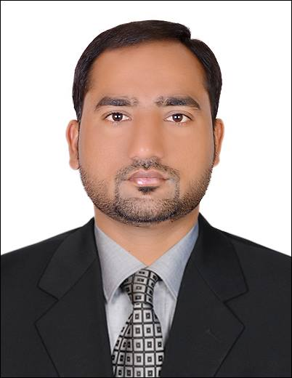
- Name : Riazwan Arif
- Experience : 5 years
- Qualification : Bachelors of Science
- Higher Qualification : B.Ed (UNIVERSITY OF BAHAWALPUR PAKISTAN)
- Nationality : Pakistani
- Date of Birth : 20th May 1984
- Contact Nos. : 00971-561480771
- Email Address : rizwanarif8773@gmail.com
- Current Location : UAE (Employment Visa )

Seeking Position: HSE Officer

Objective
To seek a responsible position as a Safety Officer within a progressive, reputed organization in order to achieve results and attain professional growth in both technical and managerial fields, while embracing new technology & strategies to remain competitive in the market.
A versatile and proven decision making Safety Professional with over 5 Years of experience on major projects. Have comprehensive experience of monitoring Industrial Health & Safety activities with Clients and Sub-Contractors and local authorities during the construction, pre-commissioning and commissioning phase of the projects.

PROFESSIONAL QUALIFICATION

- NEBOSH (IGC) from “Green World Group Dubai” UAE (2013)
- Enrolled for Abu Dhabi OHS Practitioner Course (waiting for exam)
- HABC (Fire Level 2 Certificate) form “Green World Group Dubai” UAE (2013)

work experience 05 years

ADNOC Distribution Oil terminal, Hamriyah Free Zone, Sharjah

(2014 to till date)

HSE Officer
- Reporting to Project HSE Manager.
- Preparing weekly and monthly reports.
- Enhance safety consciousness and knowledge through continuous education, training/ tool box talks, safety induction, video sessions and safety meetings.
- Controlling site safety management issues.
- Auditing site on daily basis and issuing notice of non compliance.
- Giving induction training to all workers.
- Coordinating with top management to resolve day to day HSE issues .
- Doing risk assessment for various activities in the site.
- Updating HSE related documents on daily basis.
- Keeping site HSE conditions according to Abu Dhabi municipality safety rules and regulations.
- Managing site first aid clinic and keeping up-to-date.
- Ensure use of third party tests, assembled, marked and color coded lifting tackles of adequate strength is used.
- Investigation of accident/ incident and prepare report.
- Managing the site security team.

Samsung Engineering AL HOSN GAS Project, SHAH HAMEEM (2012 to 2014)

HSE Officer
- Reporting to Project Manager.
- Conduct Site Safety Audits and Inspections to evaluate compliance with the Site Safety Policy and Procedures.
- Participate in Incident Investigation to ascertain Root Cause/s and required corrective / preventive actions.
- Supervision of all activities at site.
- Induction training for the employees and visitors
- Daily Inspection of tools and equipment used at site.
- Conducting daily Toolbox Talk to all workers regarding safe working practices.
- Preparation of monthly/weekly site safety reports.
- Routine Safety Inspection at the site and supervision of permit to work.
- Preparation of audit reports and implementation of corrective actions.
- The compilation of Risk assessment and analysis for all construction
- works carried out in accordance with Company and Client safety policies
- Daily scaffolding inspection.

Habib Rafiq Limited Civil-Pakistan (2009 to December 2011)
Junior HSE Officer
Client : Bahria Town / Defence housing ISLAMABAD
Project : Bahria Town(pahse 1-7) and Defence housing phase
- Reporting to HSE Manger.
- Inspecting all the firefighting equipment and emergency equipment.
- Conducting induction and HSE trainings for new and existing employees.
- Participate in Incident Investigation to required corrective / preventive actions.
- Daily Safety Tours, Weekly safety inspection, the compilation of Risk assessment for the main contractor and subcontractor.
- Preparation of maintenance schedule for safety and fire equipment.
- Indicating unsafe acts and conditions.
- Monitoring extension activities and coordinating between construction and operational activities.
- Ensuring the availability, quality and compliance of personal protective equipment. Preparing hazards Identification plans and risks assessments.

Languages Capabilities

- English, Arabic,
- Urdu, Hindi,
Personal Skills

- Ability to meet deadline in a fast paced environment.
- Excellent written, verbal & effectively communication skills.
- Excellent leadership, mentoring and interpersonal skills at all levels.
- Ability to work under pressure and handle multiple priorities and initiate.
- Recognizing & understanding differences & trends.
- Hardworking and result oriented young man.
- Flexible and friendly attitude.
- Good convincing power and public dealing.
- Time Management.

