CURRICULUM VITAE

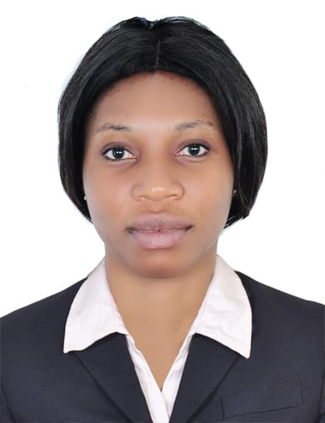
PERSONAL INFORMATION
NAME : MOKANYA MOKI AGNES
GENDER : FEMALE
NATIONALITY : CAMEROONIAN
ADDRESS : DUBAI, UAE
TELEPHONE : +971556101429
EMAIL : mokanayaagnes7@gmail.com
VISA STATUS : VISIT VISA

POSSITION: HOUSE KEEPING

OBJECTIVE
To obtain house keeping position with a Company where extensive cleaning and general maintenance skills will be fully utilized to contribute to greater efficiency and productivity.

KEY QUALIFICATIONS
• Over 3year work experience as a cleaner.
• Highly skilled in performing general cleaning and manual works.
• In-depth knowledge of special types of cleaning tools.
• Proven record of working with chemicals and dangerous materials
• Able to perform accurate and safe work.
• Demonstrated ability of prioritizing, organizing and following through on different work tasks
• Thorough understanding and capability to follow oral and written instructions.

HOUSE KEEPING SKILLS
• Cleaning methods and techniques.
• Materials and equipment used in cleaning.
• Operation of various cleaning equipment.
• Safety policies and procedures.

WORK EXPERIENCE SANTA LUCIA HYPERMARKET DOUALA CAMEROON(Jan 2016 – June 2018)
HOUSE KEEPING
• Empty, clean all waste containers.
• Hand dust and wipe clean all workplace furnishings, files, fittings, paneling and window sills.
• Damp wipe and buff all glass furniture.
• Remove waste paper and garbage from the building to designated area.
• Empty and clean ash trays.
• Clean and buff tile floor services.
• Remove all finger marks and stains from vertical surfaces.
• Vacuum all rugs and carpeted areas.

ECOBANK BONANJO DOUALA CAMEROON (June 2014 – Jan 2015)
CLEANEER
• Swept all private stairways and vacuumed carpeted floors
• Polished stairwells and damp mop spillage
• Wipe cleaned and polished all hardware fixtures
• Washed, cleaned and disinfected water coolers
• Cleaned entry door glass inside and outside
• Swept and dusted mop floors.
EDUCATIONAL BACKGROUND

Bachelor of Science (Geology)
GCE Advance Level
GCE Ordinary Level

ADDITIONAL SKILL
Good working knowledge of Microsoft word, excel and regular use of the internet. Love team work, good in adapting to changes, hard working, focused, trustworthy, intelligent, learn fast, good learning ability, good communication skills and can speak French and English.
LANGUAGES
English- speak, read and write
French- speak, read and write

HOBBIES
- Dancing and singing because it makes me active and happy.
- Socialising, listening to music and watching news because it makes me know about the world.
- Sports keeps me health and active .

