**Muhammad Wahab shaikh**

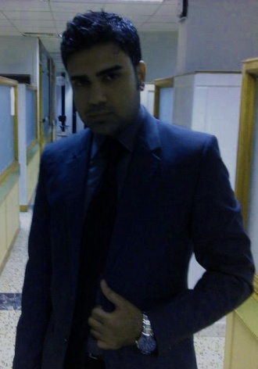 Mobile: 92-333-2699649

wahab_mysterious@hotmail.com

**Objective**

Glancing for a challenging position in progressive organization offering

Opportunities for enlargement and proficient expansion.

**Summary**

* **Profile** Male, 37, Single
* **Nationality** Pakistan
* **Current Location** Hyderabad Sindh, Pakistan
* **Father Name** Muhammad Ishaque
* **Date of Birth** 18th March 1984
* **Religion** Islam
* **Present Address** Flat No. 2, Momin Appartments, Unit No 2,

Latifabad, Hyderabad, Sindh, Pakistan.

_____________________________________________________________________________________

* **Current Position** Operation Manager
* **Company** Habib Bank Limited (HBL)

**Work Experience**

**Sep 2007- October 2019** **HBL (Habib Bank Limted)** **Hyderabad, Pakistan**

*Operation Manager*

During my service in HBL, I worked as an Operation Manager, Senior Supervisor, Junior Supervisor

Customer Service Officer, Remittance & Clearing Incharge and obtained sound knowledge and experience of almost all Retail banking designations including targets assigned by the bank related to Deposit maintenance, Personal loan, Bancassurance and Business development.

Habib Bank Limited is a well known Financial institution worldwide, which deals with a wide range of

Banking aspects and having more than 1500 hundred branches world wide.

_____________________________________________________________________________________

**Jun 2007 – Aug 2007** **Gatron Group Of Companies** **Karachi, Pakistan**

*Junior Admin Officer*

_____________________________________________________________________________________

**Teaching Experience**  **Teaching Subjects** **Classes**

Buisiness Administration, Accountings, MBA, BBA, O & A

Economics, Finance. Levels students

_____________________________________________________________________________________

**6 Weeks Intership** **NBP (National Bank of Pakistan)** **Hyderabad, Pakistan**

**Education**

**Sep 2011 – Jun 2014** **SZABIST**  **Hyderabad, Pakistan**

(Shahed Zulfiqar Ali Bhutto Institute of Science & Technology)

*Finance, MBA, GPA 3.21*

_____________________________________________________________________________________

**Jan 2005 – Mar 2007** **University of Sindh Jamshoro Hyderabad, Pakistan**

*Human Resource Management, MPA, GPA 3.24*

_____________________________________________________________________________________

**Jan 2002 – Dec 2003** **University of Sindh Jamshoro Hyderabad, Pakistan**

*B.Com, 2nd Division*

______________________________________________________________________________

**1999 – 2001**  **Board of Intermediate Hyderabad, Pakistan**

**& Secondary Education**

*Intermediate, 2nd Division*

_____________________________________________________________________________________

**1997 - 1999** **Board of Intermediate Hyderabad, Pakistan**

**& Secondary Education**

*Matriculation, 2nd Division*

**Certifications & Trainings**

* Certified in **Anti Money Laundering Pakistan Course** by **Thomson Reuters.**
* Certified in **Branch Banking Officer** from **Learning & Development department** of **Habib Bank Limited.**
* Attended training on **Gender Diversity Program** from **Learning & Development Department** of **Habib Bank Limited.**
* Attended training on **FATCA (Foreign Account Tax Compliance Act)** from **Learning & Development Department** of **Habib Bank Limited.**
* Attended training on **Anti Money Laundering and Know Your Customer** (**AML & KYC**) from **Learning & Development Department** of **Habib Bank Limited.**
* Attended training on **Cash Handling** from **Learning & Development Department** of **Habib Bank Limited.**
* Attended training on **Money Transfer** from **Learning & Development Department** of **Habib Bank Limited.**

**IT Skills**

* Certified in **Computing Fundamentals ( M.S Word, Power Point, Excel etc)** with **Internet Working.**
* Extensive knowledge of **MISYS** **Banking software.**

**Skills & abilities**

* Good presentation and documentation skills.
* Versatile individual with an extremely steep learning center.
* Dedicated & result oriented team player with the excellent communication and

Interpersonal skills.

* Strongly self motivated, resourceful and willing to assume responsibility.

**Languages**

**English**  Fluent

**Urdu**  Fluent