**CURRICULAM-VITAE**

**YUBA RAJ KHANAL**

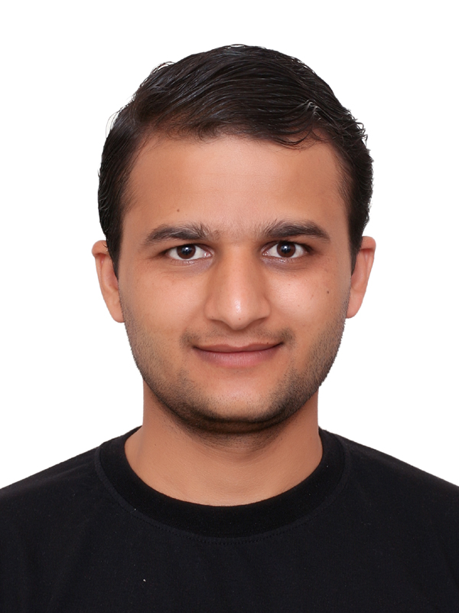

**Sharjah, UAE**

Contact No. +971-525764939(UAE)

E-mail :- khanalyuba44@gmail.com

**Career Objective**

Dedicated to sales and technical profession having wide-ranging experience with high potential seeking a sales or job where I can utilise my skills and advance my career.

**Profile**

Over 04 years of experience in dealing in **Remittance and Foreign currency exchange process, cash transactions** from clients in national and foreign currencies in **UAE Exchange**. Providing information on the conditions and exchange rates for buying and selling foreign currencies, make deposits of money, record all foreign exchange transactions and check for money validity. Fluency in English, Hindi and Nepali Languages.

**Knowledge**

* Foreign valuta
* Electronic communication
* Banking activities
* Customer service

**Work Experience**

|  |  |  |  |
| --- | --- | --- | --- |
| **Period** | **Designation** | **Organisation** | **Roles & Responsibilities** |
| 16 Mar 2017 to till now | **Sales Executive (Front Line Officer)** | UAE Exchange Centre LLC, Sharjah, UAE | Trade foreign currencies,  Maintain records of financial transactions |
| Dec 2014 to Jun 2016 | **Sales Attendant** | ADNOC Distributions, UAE | Handle financial transactions |

**Job Profile – UAE Exchange**

* Professional trained customer service officer with experience in foreign exchange operation and administration.
* Responsible for new business development as well as maintaining the existing client base.
* Document controller in office, working with Management Information System for smooth functioning.
* Foreign Remittance- remitting money to the other countries and receiving remittance, eg: Western Union, Express Money, Bill Receipt such as credit card Loan and other payouts.
* Cross selling – customer relationship, building and management, selling of products as Gold Card, Go Cash Card, Easy Top (Mobile remittance globally) and assorted national bonds.
* Closely monitor market and competitors activities to remain update in the market.
* To display the highest standard display all time. Greetings customers in a polite and enthusiastic manner, paying attention all time to their needs.
* Coordinating with other financial institutions and with their representative.

**Skills**

* Handle financial transactions
* Trade foreign currencies
* Maintain records of financial transactions
* Maintain financial records.
* Provide financial product information
* Perform clerical duties

**Training and Workshops – UAE Exchange**

* **Foundation Training for Officers** – Identifications of currencies and cash handling, Handling all kinds of transactions like TT,DD,WESTERN UNION,EXPRESS MONEY & PAYMENT Solutions.
* **Customer Service Series Training** –Best practices for Customer services.
* **Anti Money Laundering Training (AML)** –Awareness and general practices about AML and its definition, steps, threats, protective measures etc.

**Certifications & Achievements**

* Workshop on presentation skills development.
* Awarded as Best Employee of the month of March 2019 at UAE Exchange L.L.C across UAE.

**Personal** **Qualities**

* Adaptability, Knowledge and Focus on work.
* Excellent communication skills in written and verbal both.
* Keep myself calm in pressure situation. Strong sense of responsibility.
* Fast & good learner, adapt well to changes at work place.
* Work effectively with diverse group of people friendly with a good attitude.

**Educational Qualifications**

|  |  |  |  |  |
| --- | --- | --- | --- | --- |
| **Degree** | **Institute** | **Board / University** | **Year of Completion** | **% Marks** |
| **B A – Social Science** | Prithvi Narayan Campus, Pokhara Nepal | Tribhuvan University, Kathmandu, Nepal | 2011 | 54 |
| **12th Board** | Sarbodaya Higher Sec. School, Aurochaur, Nepal | HSEB,NEPAL | 2008 | 43 |

**Extra Curricular Activities**

* Travelling
* Reading novels
* In touch with global news

**Personal Details**

|  |  |  |  |
| --- | --- | --- | --- |
| **Name** | Yuba Raj Khanal | **Visa Status** | Residence |
| **Gender** | Male | **Marital status** | Married |
| **Date of Birth** | 23 Oct 1990 | **Nationality** | Nepalese |
| **Contact No** | +971-525764939 | **Address** | Abdul Aziz Tower, Near Mega Mall. Sharjah, UAE |