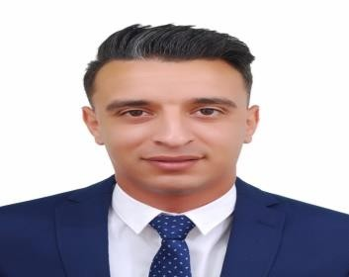

**Abdelatif Saidj**

Sales Executive

Dubai U.A.E.

Mobile No: 0504876207

E-mail : AbdelatifSaidj31@gmail.com

Adress: Union metro station, Dubai

# Curriculum Vitae

*Diverse background in sales and customer care area, Eager to maximize sales and increase profits*

Summary ــــــــــــــ

Resourceful and meticulous Sales Associate with 7 years of extensive experience in retail sales arena. Highly skilled in greeting customers with a gracious smile and helping with their shopping needs. Proven ability to suggest, choose, and help locate products based on guest needs and desires. Successfully maintains current knowledge of company’s products, marketing programs, promotions, and media plans. Known for guiding customers from the beginning to end of their sales journey.

**PROFESSIONAL COMPETENCIES**

* Merchandise Display – Greeting Customers – Replenishment and stock reports
* Deliveries Counting – Cash Register Operation – Product knowledge development
* Shipping and packaging – Cash Handling – Arabic/English/French/Spanish

Education ــــــــــــــ

* + Bachelor degree in french language ( University of Sidi Belabbes, Algeria )
  + English for communication at Gleetsy private school for 6 months

experience Work ــــــــــــــ

December *2016 –June 2021*

**Sales Associate, CELIO, Algeria**

## Detailed duties:

* + Welcomes customers by greeting them; offering them assistance.
  + Directs customers by escorting them to racks and counters; suggesting items.
  + Advises customers by providing information on products
  + Helps customer make selections by building customer confidence; offering suggestions and opinions.
  + Documents sale by creating or updating sales records.
  + Processes payments by totaling purchases, processing checks, cash, and store or other credit cards.
  + Keeps clientele informed by notifying them of preferred customer sales and future merchandise of potential interest.
  + Contributes to team effort by accomplishing related results as needed.

*September 2014- August 2017*

**Sales Executive, CITY SPORT, Oran Algeria**

## Detailed duties:

* + Maintaining and increasing sales of your company's products.
  + Reaching the targets and goals set for your area.
  + Establishing, maintaining and expanding your customer base.
  + Servicing the needs of your existing customers.
  + Increasing business opportunities through various routes to market.
  + Collecting customer feedback and market research.
  + Reporting to [senior managers.](https://www.totaljobs.com/careers-advice/job-profile/sales-jobs/sales-director-job-description)
  + Keeping up to date with products and competitors.

Languages ــــــــــــــ

Arabic, English, French and Spanish

Background Personal ــــــــــــــ

Nationality: Algerian

Date of birth: 18th November 1991 Marital Status: Single

Interests ــــــــــــــ

- Running - Football

- Gym - chess

– Movies. – Scuba diving