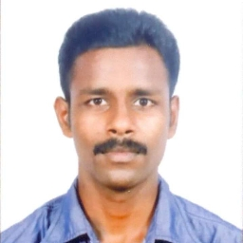**BIO-DATA**

**BINEESH DEVARAJ**

CONTACT NO- MOBILE : +971 588800853

POST APPLIED FOR : HVAC TECNICIAN

EMAIL ADDRESS : Bineeshdevaraj8@gmail.com

**PROFFESIONAL EXPERIENCE**

Workin an HVAC Tecnician for last**10 years.**

**SCOPE OF WORK**

HVAC TECHNICIAN

**JOB PROFILE**

1. Worked with**BSNL**

Designation - AC OPERATOR

Period - June 2010to jan 2011

2.) Worked with Shreyus Engineers, Cochin

Designation - HVAC TECNITION

Period - JAN 2011 to June 2013

3.) Worked with AIRMECH TECNICAL SERVICES LLC

Designation - HVAC TECNITION

Period - June 2013 to sep2017

4.) Still working AL MEMZAR CONTRACTING LLC

SKILLS

INSTALING, COMMISSIONING & MAINTANANCS All type off AC

**EDUCATIONAL QUALIFICATION**

**S.S.L.C**

MECHANICAL REFRIGERATION &AIRCONDITION ITC

**PERSONAL DETAILS**

Permanent Address-Vellar kizhakkekkara Veedu, koothali po,

Trivandrum, pin 695505 KeralaIndia.

Date of Birth -20 -5-1990

Marital Status - Married

Religion - Christian

Languages known - Hindi, Malayalam, English &Tamil

**PASSPORT DETAILS**

Passport NO -L1746944

Date of Issue -30-4-2013

Date of expiry -29-4-2023

Place of Issue -India

**DECLARATION**

I hereby declare all the details mentioned are true to the best of my knowledge.

(BINEESH DEVARAJ )