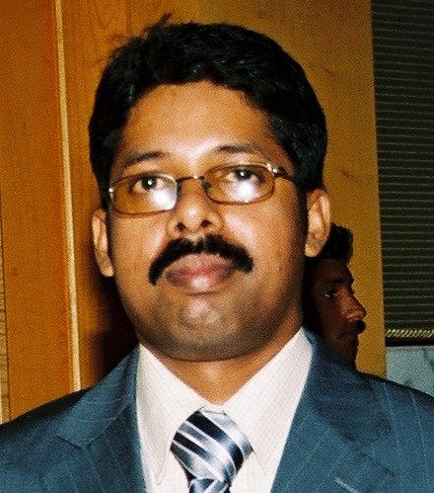

**Pratap Sivaraman,**

P.O. Box - 211072,

Dubai,

United Arab Emirates.

E-mail: Pratap.renu@gmail.com

Tel: (Mob) +971 50 9647 573.

## Objectives

To pursue a career in Accounts & Finance in a challenging work environment with responsibilities for upgrading, developing and implementing creative ideas and enhancing my skills with highest quality standard and gaining valuable experience exploiting professional and personal skills while being resourceful, innovative and flexible.

## Professional Summary

* Expertise in handling Accounts & Finance activities encompassing preparation and finalization of Accounts.
* Adept in handling payments, ensuring accuracy & correct accounting; obtaining further information to clarify & resolving variances/ discrepancies.
* Excellent negotiation, interpersonal and communication skills, good analytical skills
* Highly reliable and responsible, punctual, disciplined and energetic loyal employee.
* Excellent team player, proactive, self-motivated.
* Ability and willingness to learn more whilst working on the job.
* A Positive attitude, organized, systematic approach and hardworking
* Ability to work under tremendous work pressure with ease and efficiency.

Working as **Senior Accountant** for **Carlease Rent A Car LLC**, Dubai, United Arab Emirates since 2013

Carlease Rent A Car LLC is a limited liability company, dedicated to providing car rentals on long term & short term basis. Reporting to General Manager & Managing Director..

**Job Responsibility:**

* Cashflow management
* Co-ordinating with various banks on daily basis
* Managing the day to day financial activities of the company.
* Co-ordinating with PRO for admin & other government related activities
* Preparing monthly financial performance statements
* Controlling petty cash payments
* Liaising and assisting internal & external auditors; implement recommendations if any; to take corrective action wherever required.
* Supervising the Accounts Payable, Payroll and Management Reports.
* Reconciliation of revenue monthly and report to the Finance Manager
* Handling and Controlling accounts for 5 Branch Locations in Dubai
* Approval and authorization of all day to day treasury data entries and bank online payments

Worked as an **Accountant** for **Tropicana Trading DMCC**, Dubai, United Arab Emirates from 2006 to 2013.

Tropicana Trading DMCC is a limited liability company registered under the Dubai Multi Commodities Center (DMCC), dedicated to providing complete service and support in Oil Trading Blending and Shipping Operations. Reported directly to finance controller and vice president.

**Job Responsibility:**

* Preparing monthly financial performance statements
* Managing the day to day financial transactions of the company.
* Supervising the Accounts Payable, Receivable, Payroll and Management Reports.
* Controlling petty cash payments
* Preparing Projected & Actual Cash Flow Statements.
* Managing the Invoice Generation Operation & Credit Control.
* Checking the General Ledger entries and making sure the same are accurate and are in line with Company Procedures & International Accounting Standards.
* Finalizing Trial Balance with supporting schedules.
* Ensuring effective fixed assets & inventory control are applied.
* Checking Monthly Bank Reconciliation Statements.
* Liaising with & assisting internal & external auditors; implement recommendations if any; take corrective action wherever required.
* Providing timely & accurate Financial Information to the Management.
* Familiar with LC Documentation.

Worked as an **Accountant-cum-Office in-charge** for **Meeran Computer Company**, Dubai, United Arab Emirates from December 1998 to 2006.

Reporting directly to the Managing Director.

**Job Responsibility:**

* Responsible for the documentation work of all the purchase orders.
* Responsible for the accounts payable.
* In-charge of all the payroll activities.
* In-charge of reconciliation of banks, supplier accounts, sales turnover and credit cards on monthly basis.

## 2 Years of Experience in India

Worked as an **Accounts Assistant** for **Kirloskar Kilco Machines,** Kerala, India from November 1996 to November 1998.

## Educational Qualification

Bachelor of Commerce {Accounting main} from Kerala University, 1995.

## Additional Qualification

1. Well versed in MS Office Applications
2. Peachtree & Tally Accounting Package.

## Personal Details

Date of Birth **:** 11th March 1975

Marital Status **:** Married

Passport Number **:** G 8812590

Driving License **:** Holder of UAE Driving License

Work Permit **:** Valid till May, 2019

Hobbies **:** Listening to music, Reading

Languages Known **:** English, Hindi, Malayalam & Tamil

◘ ◘ ◘ ◘ ◘