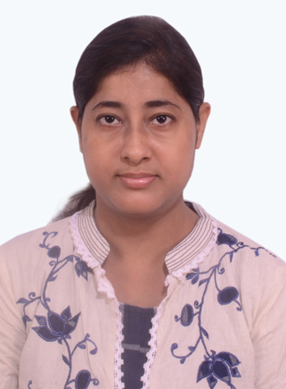 |  | RITA CHAKRABORTY
Profile  • An enthusiastic fresher with highly motivated and leadership skills having a bachelor of Arts degree in Philosophy Hons.  • Diploma In Interior Designing  • Expert in the implementation of each step of the project.  • Eager to learn new technologies and methodologies.  • Always willing to innovate the new things which can improve the existing technology.  Contact  PHONE:  +971- 559652733  EMAIL:  Sendmailtorita.21@gmail.com  perSONAL INFORMATION  NATIONALITY :- Indian  Date of Birth :- 21.01.1990  Languages Known:- English, Bengali, Hindi  VISA STATUS:- Visit Visa– (Till- 02/02/2022)  Hobbies  Cooking  Dance |  | EDUCATION  Advance Professional Course In Interior Designing (2018-2020)  GLAAMOUR FASHION AND INTERIOR  Bachelor in Arts Philosophy Hons (2008-2011)  Burdwan university  Higher Secondary Education (Arts)  West Bengal Council of Higher Secondary Education  2006 – 2008  Secondary Education  West Bengal Council of Secondary Education  2004-2006  TECHNICAL SKILLS  - Autocad 2d Sketch  - Advance Office Practice  - MS WORD & MS EXCEL  SKILLS  - Communication  - Teamwork  - Adaptability  - Punctuality  - Organization  - Flexibility  - Problem Solving Abilities  - Motivation  - Patience

