AFSAL Y
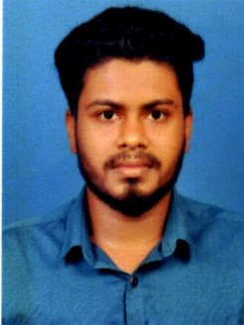  Contact Details:-  Mobile No :- 050-6912009  050-1660071  GMAIL  afsalyusuff777@gmail.com  Personal Details:-  1)DOB:-  19/04/1998  2)SEX:-  MALE  3)NATIONALITY:-  INDIAN  4)RELIGION:-  ISLAM  5)MARITAL STATUS:-  SINGLE  6)NAME OF FATHER :- S  YUSUFF KUNJU  7)NAME OF MOTHER:-  LEENA T | OBJECTIVE  To obtain a job within my chosen field that will challenge me and allow me to use my education, skills.  EDUCATION QUALIFICATION  - Higher Secondary School (Plus Two) from NIOS Kerala, India-Passed 2019  - Secondary School Leaving Certificate (SSLC) from ST.AUGUSTINE’S H S MURUKKUMPUZHA Kerala, India- Passed 2015  - DIPLOMA IN FIRE & SAFETY (2018)  - TTC SCHOOL OF HEALTH AND SAFETY IOSH M S-2018 (MEDIC FIRST, RISK ASSESSMENT, AUDITING AND INSPECTON SKILLS, INCIDENT INSPECTION  EXPERIENCE  - SIMPLEX INFRASTRUCTURE LIMITED  SAFETY APPRENTICE at Mangalapuram Trivandrum  25 August 2018 to 15 March 2019  - PERFEECT SAFETY & SECURITY SYSTEMS  FIRE AND SAFETY SUPERVISOR at Cheruvakal Trivandrum  01 April 2019 to 30 March 2020  - V – TECH ENGINEERING AND FABRICATIONS  FIRE AND SAFETY SUPERVISOR at lulu Mall Trivandrum  06 April 2020 to 31 March 2021  LANGUAGE SKILLS  - SPEAK : English, Malayalam.  - READ : English, Malayalam, Hindi.  - WRITE : English, Malayalam.  PERSONAL SKILLS  - Interest to Learn.  - Willingness to adopt any kind of environment.  - Well organized and good time management.  - Alert and self motivated.  DECLARATION  I hereby declare that the details given above are true and correct to the best of my Knowledge and Belief.  Place :  Date :-

