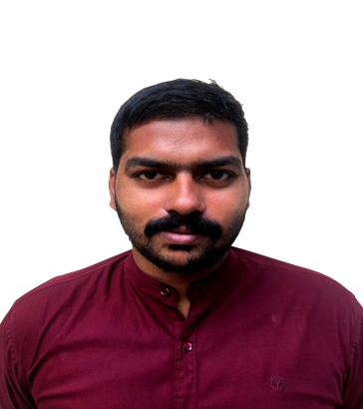

**EXPERIENCE**

**Team Leader July-Dec 2020**

NTEX TRANSPORTATION (ELASTIC RUN)

Iritty, Kerala

* Receiving load
* Authorizing delivery of shipments
* Cash collection, UD Validation and Cash Deposit

**Internship Jun – Aug 2019**

KARASSERY SERVICE CO-OPERATIVE BANK

Mukkam, Kerala

* Handled bank financial/Accounting documents
* Customer deals service
* Information translation from English to Malayalam

**Senior sales Executive Aug 2016- Jul 2018**

APPAI FOODS

Kozhikode, Kerala

* Introduced APPAI food products around 200 shops
* Promotion and sales of products to retail market
* Inventory stock audit
* Training of new sales personnel

**SKILLS**

1. Proficient with Microsoft Office (Word, Excel, Power Point) and working on Internet
2. Sales Strategy
3. Team management - skilled in delegating tasks and motivating team players to achieve goals.
4. Quick learner
5. LANGUAGES: Fluent in English and Malayalam, Intermediate in Tamil and Hindi
6. Dynamic attitude and efforts with self-confidence

**PERSONAL DETAILS**

Date of Birth: 25 September 1993  
Marital Status: Single

Driving License: Yes  
Permanent Address: Chandrankunnel, Kodanchery, Kerala, 673580

E-mail: [Sachin99900@gmail.com](mailto:Sachin99900@gmail.com%20)

Mobile: **+91-8921601029**

SACHIN MATHEW  
 MBA Graduate

Result-driven, organized and self-motivated MBA graduate seeking a management job in an effort to utilize my theoretical knowledge and experience to fulfil the company’s goals.

**MY PROFILE**

**EDUCATION**

* **Master of Business Administration (**June 2020)

Vignan’s foundation for science technology and research

with 70 % in Marketing and Operation management

* **Bachelor of Commerce** (June 2016)

Don Bosco college, Calicut University

With 65 %

* **Intermediate** (June 2013)

Auxilium Nava Jyothi School, Calicut, Kerala

With 63%