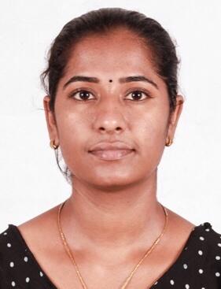

**JYOTHY SOLOMON**

PONNUMPARAMBIL(H),

CHERANALLOR(P.O)

ERANAKULAM (DIST)

KERALA ,INDIA PHONE :+971526978746

PIN:683544 <jyothysolaman63@gmail.com>

|  |
| --- |
| OBJECTIVE |

To pursue a highly challenging and creative career, where I can apply my existing

Knowledge and creativity acquire new skills and contribute effectively to the organization.

|  |
| --- |
| SOFTWARE SKILLS |

ASP.NET,C#,HTML,CSS,SQL

|  |
| --- |
| WORKING EXPERIENCE |

1. Working as a software trainee in Quest Innovative Solution Pvt. Ltd Eranakulam

2. Working as a software trainee and developer in Right soft solution kaloor,Eranakulam.

|  |
| --- |
| EDUCATIONAL BCAKGROUND |

|  |  |  |  |
| --- | --- | --- | --- |
| **YEAR OF PASSING** | **UNIVERSITY/BOARD** | **PROGRAM** | **PERCENTAGE** |
| 2016 | Anna university | BE (Computer science and engineering ) | 70 |
| 2013 | Department of Technical education (tamil nadu) | DIPLOMA (Computer Engineering) | 93 |
| 2008 | State board of kerala | SSLC | 74 |

|  |
| --- |
| PERSONAL STRENGTH |

Adaptability, Problem Solving Skills, Conflict Resolution and Team Work.

|  |
| --- |
| PERSONAL DETAILS |

|  |  |
| --- | --- |
| Date of Birth | 30/10/1991 |
| Marital Status | Married |
| Father’s Name | Solomon |
| Gender | Female |
| Passport Number | P3992866 |
| Place of Issue | Cochin |
| Date of Expiry | 31/07/2026 |
| Nationality | Indian |
| Languages Known | English, Malayalam, Tamil. |
| Strength | Ability to deal with people diplomatically, Hard Worker  Comprehensive problem solving abilities |
| Visa status | Husband visa |

|  |
| --- |
| DECLARATION |

I hereby declare that all the information furnished above is true to the best of my knowledge and belief.

Date: JYOYHY SOLOMON

Place: