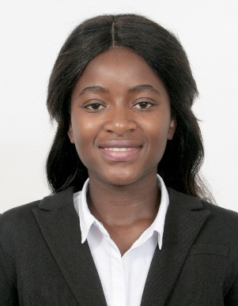 **Cleaner**

CHARMAINE CHIDYAUSIKU

**Personal Summary**

**Address**

**Villa 6 20 A Street**

**Al Barsha**

**Dubai**

**Mobile Number**

***+971501646988***

**Email**

**ctcchidya@gmail.com**

**Marital status**

*Single*

**Nationality**

*Zimbabwean*

**Proficient Language(s)**

*English*

**Date of Birth**

*21 July 1999*

**CN080063**

A talented, enthusiastic and competent cleaner who has experience of the daily cleaning of all areas within both commercial & residential buildings. Helping to make a pleasant environment for both staff & customers. Having a ‘can do’ attitude and able to ensure that all environments are kept clean and tidy to a high standard. Physically fit and able to perform demanding duties such as lifting, pushing and pulling objects, bending and kneeling down. Now looking for a new and challenging position, one which will make best use of existing skills and experience and also further my personal and professional development.

**Professional Experience**

**HOTEL UTILITY**

**Arrow Creek Spur Steak Ranch (South Africa) Feb 2017 – Dec 2019**

Working as part of a team and responsible for various cleaning duties to ensure the cleanliness of the building. Complying with all proper safety policies and procedures when using cleaning chemicals. Making sure that COSHH regulations are adhered to on the use of chemicals, protective clothing and equipment.

**Duties and Responsibilities**

* Cleaning of offices & furniture by hovering, dusting and polishing
* Taking away clothes and cloth material for dry cleaning.
* Training new employees in cleaning procedures.
* Ensuring the hallway, stairs and windows are cleaned to a high standard. Responsible for mopping, sweeping, brushing & vacuuming.
* Washing dishes in the kitchen and replenishing kitchen supplies.
* Making sure windows and doors are securely closed.
* The emptying of all waste bins and removing waste to designated areas. Attend monthly team meetings with managers to give feedback
* Cleaning offices, reception area and also washrooms and lavatories. Cleaning and dusting of all interior surfaces, fixtures and fittings. Maintaining a safe and secure working environment.
* Mopping & disinfecting all WC, floor surfaces and replenishing bathroom supplies.

**KEY SKILLS AND COMPETENCIES**

* Passion about hygiene

**Skills**

**Professional Skill**

MS Word, Adobe, MS PowerPoint. High attention to detail, Polite and helpful. Patient and Diplomatic when dealing with complaints.

Flexible and Reliable.

Good memory.

**Personal Skills**

**Bright, Friendly, Customer Courteous, Strong verbal and written communication skills, ever smiling, Enthusiastic**

* Flexible reliable and be able to work at a fast pace.
* Reporting any defective equipment or safety concerns to the Cleaning
* Supervisor. Experience of cleaning public areas in a retail environment.
* Can work well in a busy and demanding environment.
* .Experience of cleaning both offices and also factories.
* Can communicate effectively at all levels

**EDUCATIONAL QUALIFICATIONS**

**Standard passed: Ordinary level**

**AREAS OF EXPERTISE**

* Knowledge of COSHH
* Vacuuming
* Health & Safety
* Polishing
* Recycling
* Dusting
* Cleaning chemicals

**References available upon request**