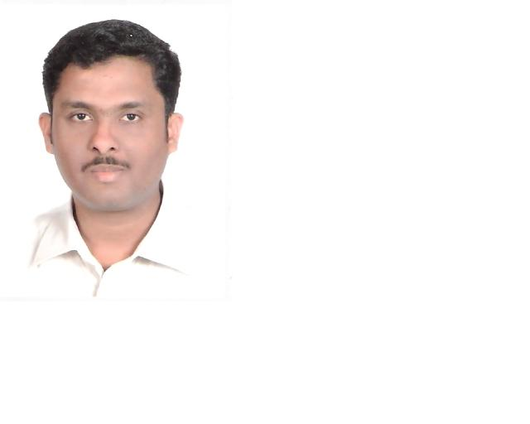
MOHAMMAD NAEEM
U.A.E.
Mob: 00971-504287188
E-Mail: naeem63471@yahoo.com

PROFILE:-

Looking forward to a stimulating career in the customer service industry, preferably with a Multi-national, at middle-management level. Seeking a position which will effectively utilize my experience. looking forward to joining a progressive organization that has a need for my kind of candidature and that offers me the opportunities for future growth.

GULF PROFESSIONAL EXPERIENCE:-

Worked as a sales assistant in AL SERB Gents Tailor in abu dhabi from 23 September 2020 to 01 October 2021.

JOB PROFILE:-

- Interacting with the customers.
- Taking order and information on order
- Following the order in workshop
- Checking in orders on dates and quality of stitch
- Maintains the store are clean and organized
- Receiving merchandise
- Displaying the items
- Collecting the payment

Worked as a SALESMAN with
AL ANOOD (Al ain, Abu Dhabi, UAE), from 04th June 2004 to 19th February 2020

JOB PROFILE:-

- Develop profitable business and accelerate existing ones.
- Responsible for the achievements of sales goals.
- Maintains stock level perfect & tracking every week sales figure,
To make stock available on floor & solving ground level sales problems.
- Giving assistance to customers in locating merchandise.
- Trains new sales staff in basic operations and procedures.

INDIA PROFESSIONAL EXPERIENCE:-

Worked with CYBER ZONE, Mangalore as a Operator from Nov 2001 To May 2004.

In Year 1999 to 2001 worked for COMP U TECH as a Salesman And Hardware Eng.

STRENGTHS:

Ability to maintain cordial relation with colleagues and customers.
Ability to communicate effectively and with conviction.
Result oriented, hard working, devoted and self-motivated.
Can work under pressure and love to accept challenges.

ACADEMIC QUALIFICATION:-

Passed S.S.L.C in the year 1996 with Karnataka Board.

I.T.I Electronic mechanic in A.G. Soans I.T.C in moodbidri
Diploma in Hardware’s eng. In I.I.H.T at Mangalore

PROFESSIONAL COMPUTER SKILLS:

Office Package : DIPLOMA IN MS Office Automation
(Word, Excel, PowerPoint)
Operating System : Windows 98/2000

PERSONAL DETAIL:-

Father’s name : Late. MOHAMMAD GOUSE
Date of Birth : 16-03-1980
Gender : Male
Status : Married
Nationality : Indian
Visa status : visit visa
Languages Known : Arabic, English, Hindi, Urdu and Kannada.

PERSONAL INTERESTS

Shopping | Travelling| Reading | Football| Cricket

REFERENCES

Mohd Naeem

