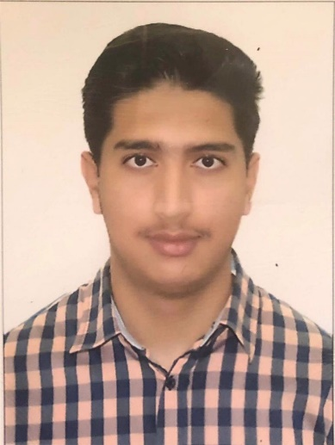  Contact  Address : Dubai, U.A.E  Address : Dubai, U.A.E  Phone : 056-8824589  Email : Faizan.233329@gmail.com  Skills  - Strong verbal communication  - Microsoft Office  - Google Drive  - Well organized  - Self-motivated  - Team leadership  - Fluent in [English]  - Attention to detail  - Communication skills  - Powerful negotiator  - Extremely organized  - Budgeting  - Data management  - Staff development  - Scheduling | Muhammad Faizan Haider  Professional summary  Experienced professional with strong leadership and relationship-building skills.  Exceptional leader talented at Microsoft office,computer management and customer service. Technically-savvy with outstanding relationship building, training and presentation skills.  Work history  Sales promoter 10/2019 to 10/2019  GItex-Dubai,U.A.E  - Scheduled appointments with potential customers for product installation.  - Addressed prospect concerns and utilised persuasive techniques to turn patrons into paying, satisfied customers.  - Used outstanding communication and interpersonal skills to quickly build positive customer relations for effective deal closing.  - Delivered an exceptional level of service to each customer by listening to concerns and answering questions.  Volunteer Worker 07/2019 to 08/2019  Dubai Mall - Dubai, U.A.E  - Drove customer feedback to deliver information to management for corrective action.  - Developed and implemented record management procedures.  - Maintained reception area in orderly manner to provide visitors with positive first impression of company.  - Adhered to security requirements by screening visitors, updating logs and issuing temporary passes.  Education  2016-2018: Secondary school certificate His highness sheikh rashid al-maktoum pakitsani school dubai,U.A.E  2018-2020: Higher secondary school certificate  His highness sheikh rashid al-maktoum Pakistani school Dubai,U.A.E  Personal information  Nationality: Pakistan  Sex: Male  country of residence: U.A.E  Visa status: Father visa  Date of birth: 04/12/2001  Languages  Fluent in English
.

