Amin Elimam  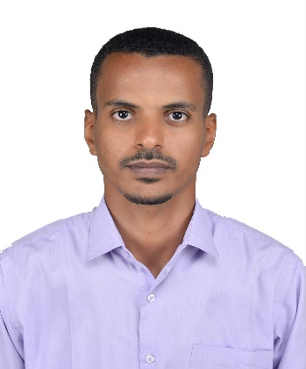    Sales Engineer  Jumeriah Village Circle, Dubai, United Arab Emirates.  aminmohammedelamin@gmail.com  +971582246128 |  | OBJECTIVE  I am an accomplished Petroleum & Natural Gas Engineer with a Master’s Degree in Mechanical Engineering (specialized in Renewable Energy). I have more than five years of professional experience in oil and gas field operations and equipment maintenance and one year as a Technical Marketing Engineer. I inspire to take a challenging role and make significant contributions in the multiple disciplines of Petroleum, Mechanical and Sales Engineering in the UAE.  SOFTWARE SKILLS - Petroleum Engineering: PIPESIM, Ecrin, Oil Field Manager (OFM), Petrel, Eclipse, CMOST. - Mechanical Engineering: ANSYS (CFD), AutoCAD, Engineering Equation Slover (EES), TRNBuild, CombiSys. - Renewable Energy Engineering: System Advisor Model (SAM), Biodiesel Analyser, NRG, BioGC, ProSim Plus, fantallometrik, Leapfrog Geo. - Others: Excellent command of Microsoft Office Suite, ArchiCAD and Photoshop. KEY SKILLS - STEM (science, technology, engineering, mathematics) skills with desire to learn. - Ability to work as part of a team. - Strong analytical mind and computer modelling skills. - Creative thinking and pay attention to detail. - Leadership and management skills. - Carpentry, pluming, welding, survey, lathing, electrical and mechanical background. - Valid Driving License.  WORK EXPERIENCE  Rig Equipment Performance Engineer  National Upstream Solutions Co. Ltd. - Sudapet~ August, 2015 – June, 2020.  Responsibilities:  - Work closely and assist both Rig Supervisor and Rig Manager on every aspect during operations as a technical advisor.  - Supervise and perform all jobs relevant to Drilling, Well control and completion operations.  - Responsible of all drilling crew, chief electricians and mechanics and technicians.  - Prepare and document daily Operations and Maintenance Reports.  - Collect all equipment name plates, specifications and manuals.  - Issue out-source service requisitions, ordering and accepting spare parts.  - Diagnosing equipment breakdowns and failures, set maintenance and repair plans, supervise it and finally prepare Failure and Repair Reports.  - Working out proposals for rig equipment upgrading and modification and apply best practices to profitably deliver improved services to clients.  - Supervise and cooperate with third party inspection and service companies to achieve desired results.  - Scheduling and applying Corrective, Preventive and Predictive Maintenance of all Drilling Equipment and Engines (Including: CAT, VOLVO, XCMG, Cummins, TOYOTA and Mitsubishi, etc.)  Projects:  Oil Drilling and Service Rigs, Oil Field Base Camp.  Technical Marketing Engineer  SHFRA Multi Activities Co. Ltd. ~ October, 2014 - August, 2015.  Responsibilities:  - Work closely with teams across the company to research market opportunities and challenges.  - Gather and prioritize product and customer requirements.  - Develop strategic product plans and drive appropriate development, sales and marketing activities.  Projects:  Petroleum equipment, Mining equipment, water treatment, Fertilizers, Animal wealth, Fluid tanks, etc.  UNDERGRADUATE TRAINING  Field Engineer Trainee  Greater Nile Petroleum Operating Company – Sudan ~ Two weeks ,2014.  Drilling, casing, mud system, cementing, tripping and pressure testing operations.  Field and Office Engineer Trainee  PETROENERGY – Balila, Sudan ~ Six weeks ,2012.  Directional drilling, hole casing, cementing, reservoir, production and perforation.  QUALIFICATIONS  MSc in Mechanical Engineering: Renewable Energy (with Merit)  University of Khartoum, Sudan ~ 2017-2019.  BSc (Hons) in Petroleum and Natural Gas Engineering (with Merit)  University of Khartoum, Sudan ~ 2009-2014.  LANGUAGES  English – Proficient/Bilingual (ILR Level 5).  Arabic – Proficient/Mother tongue.

