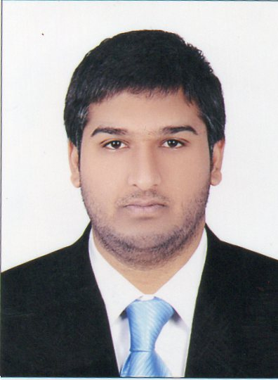

**ARSLAN TARIQ**

**Mobile No in UAE:0971-557301668**

**Email ID:** [**matariq.88@live.com**](mailto:matariq.88@live.com) **–** [**atbhatti.88@yahoo.com**](mailto:atbhatti.88@live.com)

**Dubai, UAE**

|  |
| --- |
| **Objective** |

To excel in career oriented position in a profession progressive organization where by mutual growth and prosperity is under lined execution of duties to the best of my abilities and establishing a position of trust, prosperity and confidence with the company.

**Work Experience in GULF:-**

* **Worked as a Driver with QBG company in Dubai, UAE from 27th October 2018 to 28th October 2019.**
* **Worked as a Driver Temporary Gargash Mercedez HR Department and PRO Department from 13th March 2019 to 25th April 2019.**
* **Worked as a Driver Temporary Gargash Real Astate property and Gargash Real Astate Account department 10th July 2019 to 08th Aug 2019.**
* **Worked as a PATROLING SECURITY with SERVE U LLC in Dubai, UAE from 3rd June 2014 to 25th May 2018.**
* **Worked as a SECURITY GUARD with SERVE U LLC in Dubai, UAE from 2nd June 2012 to 2nd June 2014**
* **Worked as a ADMINISTRATOR with SWEEDISH INSTITUTE OF TECHNOLOGY in Pakistan from 1st December 2008 to 24th April 2012**

**UAE Driving License Details**

* License No : 1999284
* Date of Issue : 03/02/2014
* Date of Expiry : 03/02/2024
* Place of Issue : Dubai, UAE
* Vehicle Permitted : Light Vehicle

**Key Skills**

* Outstanding interpersonal and communications skills.
* Experienced in various trading aspects.
* Detail oriented and efficient.
* Proficient in Microsoft Office, Internet applications and various Windows applications.

**Academic Qualification**

* SSC Matriculation (Science). 2005

**Technical Qualification**

* One Year Electronics and Computer Hardware 2006
* Three Months Computer Networking 2007

**Computer Knowledge**

* Operating System: Window – 2000/ XP/ Vista/ Window 7
* Ms. Office Packages
* Email & Internet

**Personal Strength & Attributes**

* Good Communication, self –confidence, Discipline and punctual.
* Self-Confidence and Interested to learning more.
* Honest and Hard working Capacity.
* Pleasing manners and can easily get along with different people.
* Having good convincing Capacity.
* Able to grow positive relationship with client, Supervisor & Colleagues

**Personal Profile**

* Full Name : ***ARSLAN TARIQ***
* Father’s Name : Muhammad Tariq Bhatti
* Date of Birth : 03/04/1988
* Gender : Male
* Religion : Islam
* Nationality : Pakistan
* Marital Status : Married
* Language : English & Urdu

**Passport Details**

* Passport No : BC 79695522
* Date of Issue : 05/05/2014
* Date of Expiry : 03/05/2024
* Visa Status :. Visit
* Date of Expiry Visa. :. 07/01/2021

**Declaration**

I hereby declare that the above mentioned statement is correct & true to the best of my knowledge & belief.

Place: Dubai

Date: ***ARSLAN TARIQ***