*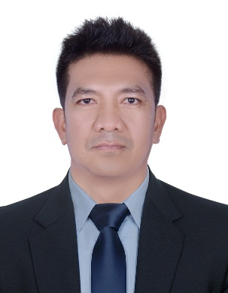NAME : RITZIE L. YAP*

*MOBILE # : 058 6262658*

*EMAIL ADD : richpoor974@gmail.com*

*ADDRESS : Al-Satwa Dubai, UAE*

***OBJECTIVE:***

*To pursue a career in your growth-oriented organization for personnel development and to contribute significantly by utilizing my potential, in making the organization achieve its long-term goal*

***KEY SKILLS:***

* *Showing initiative, problem solving and decision making skills.*
* *Ability to work under pressure and with less supervision.*
* *Excellent customer service and customer handling experience*
* *Quick learning and hard working.*
* *Independent and self-motivated.*
* *Organized and best structured work.*
* *Easy to get along with.*
* *Ability to work in a team*
* *Excellent communication and interpersonal skills, ability to lead people*

***WORK EXPERIENCE:***

***Position*** *:* ***DRIVER***

***Employer :*** *Bait Al Ahlam*

***Address :*** *Al Yarmook Sharjah U.A.E.*

***Duration :*** *2016-2018*

***Position*** *:* ***FAMILY DRIVER***

***Employer :*** *Europian, Family*

***Address*** *: Al Satwa Dubai U.A.E*

***Duration*** *:* ***2013- 2015***

***Position*** *:* ***WAREHOUSE ASSISTANT***

***Employer :*** *Al Yasra Fashion*

***Address*** *: DAFZA Dubai U.A.E.*

***Duration*** *:* ***2011 – 2013***

***Position*** *:* ***LIFEGUARD***

***Employer :*** *M.A.B Facilities Management* ***(****Emaar Properties)*

***Address*** *: Dubai U.A.E*

***Duration*** *:* ***2007 - 2011***

***Position :*** *Security Guard*

***Employer :*** *Asian Terminal Incorporated*

***Address :*** *Batangas, Philippines*

***Duration : 2004-2006***

***EDUCATIONAL BACKGROUNDS:***

* *Tertiary :* ***PHILIPPINES MARITIME INSTITUTE***

*Course Bachelor of Science in Marine Transportation*

*Manila – Philippines*

***PERSONAL INFORMATION:***

***NATIONALITY*** *: Filipino*

***DATE OF BIRTH***  *: October 26th 1977*

***GENDER*** *: Male*

***RELIGION*** *: Christian*

***CIVIL STATUS*** *: Married*

***LANGUAGES KNOWN*** *: English, Arabic, and Tagalog*

***LICENSE :*** *Valid Dubai Driving License*

***PASSPORT NO*** *:EC5823766*

***VISA STATUS***  *: Visit Visa*

***DECLARATION:***

***I hereby declare that the information given is correct to the best of my knowledge and that I have not withheld any information which may affect my suitability for employment.***

***ritzie largado yap***

*(Applicant)*