AKHIL ASHOKAN
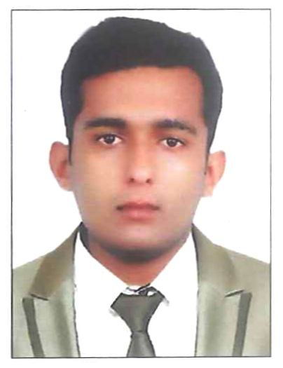
Mobile: No. +971 52 396 0749
Email: akhilacku805@gmail.com

PROFILE
A suitable position with an organization where I can utilize the best of my skills and abilities that fit my education, skills and experience. I want to actively participle and contribute to the development of the company.

work experience
5years’ experience in Operations Department and communication department

currently working as an office coordinator' the luxury collection ajman Marriott
worked as a Department admin coordinator in Marriott international TheRitzcarlton Ras al khaima

Additional skills
- Good communication skills
- Strong sense of responsibility and self motivated
- Hard Working
- Good knowledge about property management system- Opera, Oasys payroll, and Birch street
- Good leadership
- Good knowledge of MS Office
- Good knowledge of hospitality operations
- Pre-opening experience as a Cordinator
- Good knowledge as a shift incharge
- Good knowledge about productivity, and manning
- Good knowledge about bayan and adaco system
- Good knowledge of administration works

Languages known
Hindi, English ,Tamil

educational qualification
- Intermediate
- DCA (Diploma in Computer Application)
- Tally computer application
- BA

Passport Details
Passport No : M 9128619 Date of Issue : 20-05-2015
Place of Issue : Vaikom, Kerala Date of Expiry : 19-05-2025

declaration
I hereby certify that the above information is true and correct according to the best of my knowledge and my experience. If selected I assure that I would perform to the best of my abilities. Eagerly awaiting a positive response.

AKHIL ASHOKAN

